Swimming at Christ Church CE Primary School

Dear Parents and Carers,

We are delighted to announce that for three weeks from 27th June until 15th July 2022, Elite Sports Development Company will be bringing swimming to our school with their portable swimming pool. They will provide swimming opportunities for every child across our school. A qualified swimming instructor will lead the sessions, supported by a lifeguard. All sessions will last for 30 minutes.
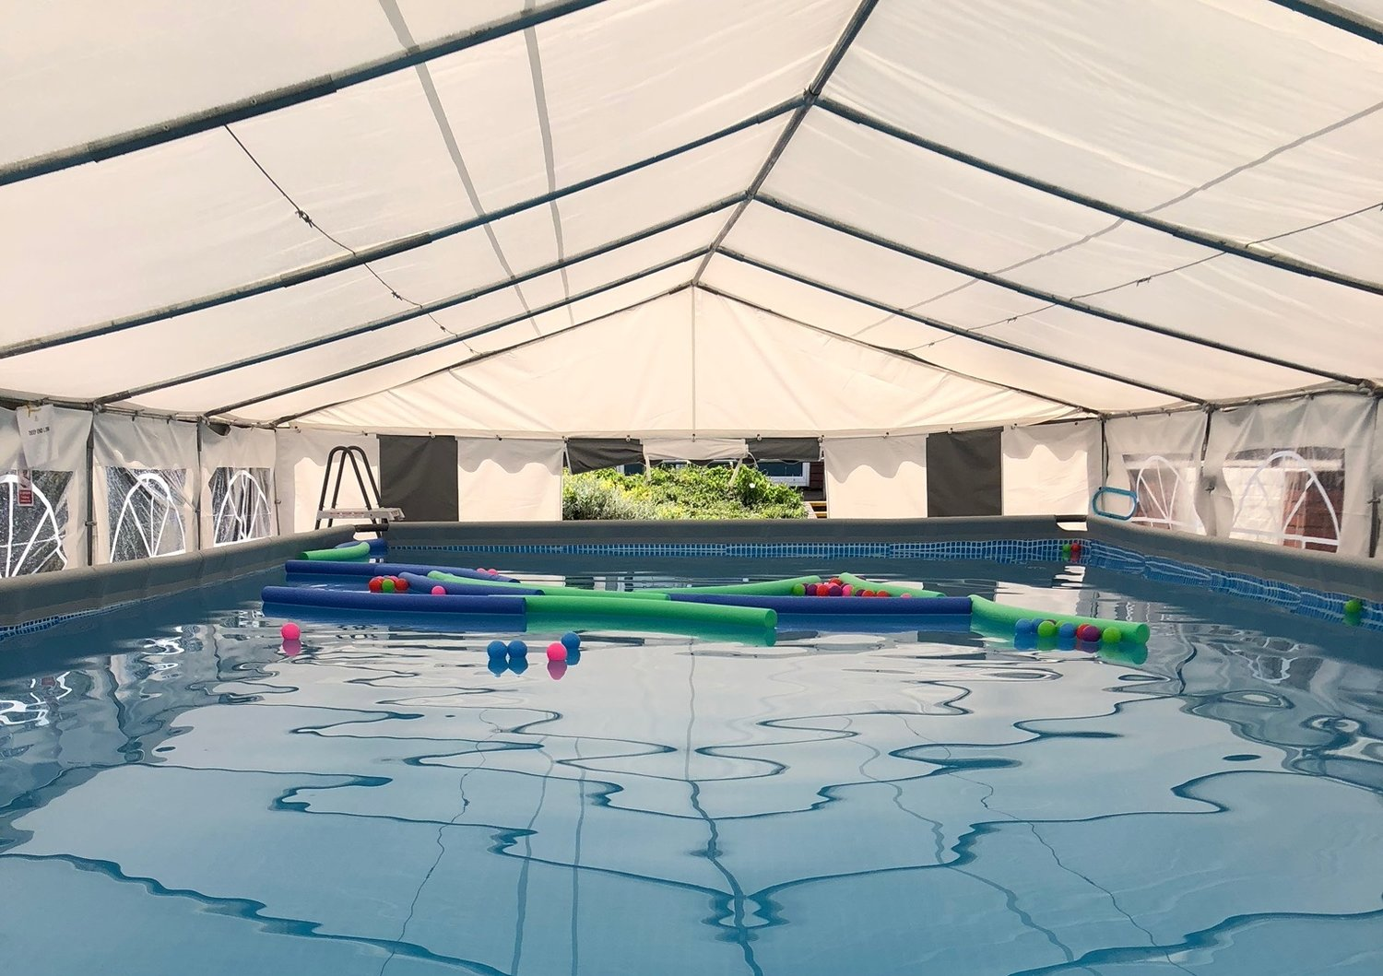

Changing facilities

Changing gazeebos will be situated next to the swimming pool. Should the weather be particularly cold or wet, children will change in their year group toilets as an alternative.

Swimming attire
Children must wear the appropriate swimming costume which they may wear under their PE kit / joggers on the day of their lessons:
- Girls – a one-piece swimsuit.
- Boys - swimming trunks.
Bikinis or long, baggy shorts will not be permitted.

Health and Safety

Jewellery must be removed before entering the swimming pool, but if ear-studs have been newly put in, then they may be covered with a waterproof plaster.

Hair is to be tied back and neither swimming caps nor goggles should be worn. Please remember, that in the event of your child being involved in a hazardous water situation, it is extremely unlikely that he/she would be wearing goggles. It is best therefore that your child learns to swim without being dependent on goggles.

A lifeguard and swimming instructor will lead every session and school staff will support children as need.

Timetable

Please ensure that your child has their swimming costume and towel in school on the day listed below.

Week 1 (27.6.22) | Week 2 (4.7.22) | Week 3 (11.7.22)
F2 water fun sessions will be arranged throughout the week  Year 5 (each day)  Year 6 (each day) | F2 water fun sessions will be arranged throughout the week  Year 4 (each day)  Year 3 (each day) | Year 1 (each day)  Year 2 (each day)

This is such an exciting opportunity for all of our children to become more confident in the water, as well as improving their general health, fitness and well-being.

Thank you for your continued support.

The Christ Church Team

