Tuesday 26th April 2022

Re: Year 5 Pupils Starting Secondary School in Sept 2023
Information for 11+ Entry Examinations

Dear Parents and Carers,
Please find some follow up to questions we are often asked about 11+ testing to assist you. Several families have requested an individual conversation to discuss their child’s attainment and Non Verbal and Verbal Reasoning Scores. It is not necessary for Primary Schools to undertake these types of tests, however we find that they give us a good indicator of pupil potential and we can compare with their national curriculum attainment. They are also a good indication of how pupils may fair at Grammar Schools.

We will contact you and arrange a convenient time to meet or telephone you. If you did not request an appointment, but would like to speak with me, it is not too late – please just let the school office know and we will add you to the contact list.

FAQs
When do I apply for an 11+ test?
If you would like your child to be entered into 11+ examinations for Wirral Grammar Schools, you must have completed the on-line registration by 31st May. The portal does not open before the 1st May, so we will send a reminder and website link out nearer the time. If you would like your child to sit the entry examination for Catholic Grammar Schools (St. Anselms or Upton) you should contact the school direct and register for the test.

St Anselm's College's entrance examination registration is now open. Click here to open their registration page. The examination is due to take place in September 2022. You can also find their sample examination papers here.

Upton Hall's admissions form is now open – click this link to register your child for the examination: https://www.uptonhallschool.co.uk/form/?pid=1709&form=19

Birkenhead High School Academy have not yet opened their admissions for this year, but you can find their admissions page and details about the music aptitude test here.

When will my child sit the test?
Your child will sit two tests on the same day with a short break in between them. You will be contacted during the summer with your exact date and time and the arrangements for the test, but they are planned to go ahead during September 2022. You will then know the outcome of your child’s test results before you have to complete your secondary admission choices in October 2022.
Are the 11+ tests the same as when older siblings took them?
The test has changed in recent years; they can no longer be taken in the child’s primary school and are sat in the Grammar Schools themselves. The test focus on the following four areas:
- Non-verbal reasoning,
- Verbal reasoning, vocabulary and spelling,
- Mathematics
- Reading and comprehension in English sections.

The test provider changed in 2020 and is now GL Assessments. GL assessments have readily available familiarisation materials and sample papers which can be accessed using the following link:
https://www.gl-assessment.co.uk/products/11plus-series-11-plus-practice-papers/11plus-familiarisation-materials/

What is the pass mark?
The four Wirral Grammar schools have a standardised pass mark of 236, as does Upton Hall. The other schools allocate places to children based on their test result ranking, so there is no official pass mark, and the lowest qualifying score will vary from year to year.

Where can I find out more information?
By contacting Wirral secondary school admissions:
https://www.wirral.gov.uk/schools-and-learning/school-admissions/apply-primary-or-secondary-school-place#wgSM-1

This site has all the information needed and links to register for 11+ testing. You can also download the Wirral 11+ Test Familiarisation guide here:
https://www.wirral.gov.uk/sites/default/files/all/schools%20and%20learning/School%20admissions/Wirral%20Familiarisation%20Guide.pdf

Does my child need a tutor?
The Local Authority state that pupils do not need to be tutored to pass the 11+, however they will need to be familiar with test techniques and this type of test will be new for them. Learning to work to time and complete all sections, as well as identifying what the question is asking and how to fill in the answer sheet are all important to help your child access the test. The more they practice, the more they will be able to work at speed successfully and the less anxious they will be on the actual day. Primary Schools cannot recommend tutors, but there are many Wirral websites that you can search if you decide this is something you want to enquire about.

How do I know if my child should sit the 11+ test?
It is important that you think not just about the test itself, but about the expectations of Grammar schools. Pupils attending grammar schools must be able to cope with the academic expectations and should currently be working at higher levels in primary school. Their results and school work should be consistently above average in order that they are not placed under undue pressure in an 11+ situation.

What can I do to help my child?
Vocabulary is a key area of the 11+ test, so anything you can do to help your child broaden their vocabulary and use of language will be beneficial. Read the newspaper together and highlight new words; get your child to look up their meaning and find other similar words (synonyms) or words with opposite meanings (antonyms). You can also use example vocabulary lists to work through and help your child know and understand new vocabulary – an example can be found on this link: https://www.11plusguide.com/wp-content/uploads/2017/05/11Plus-Vocabulary-List.pdf?utm_source=website&utm_medium=link&utm_campaign=Vocab%20List
Listed below are some links to free resources that you can access to support your child to prepare for the 11+ test. If you click on the blue type the links should take you straight to the relevant documents:

Links to high quality free resources:
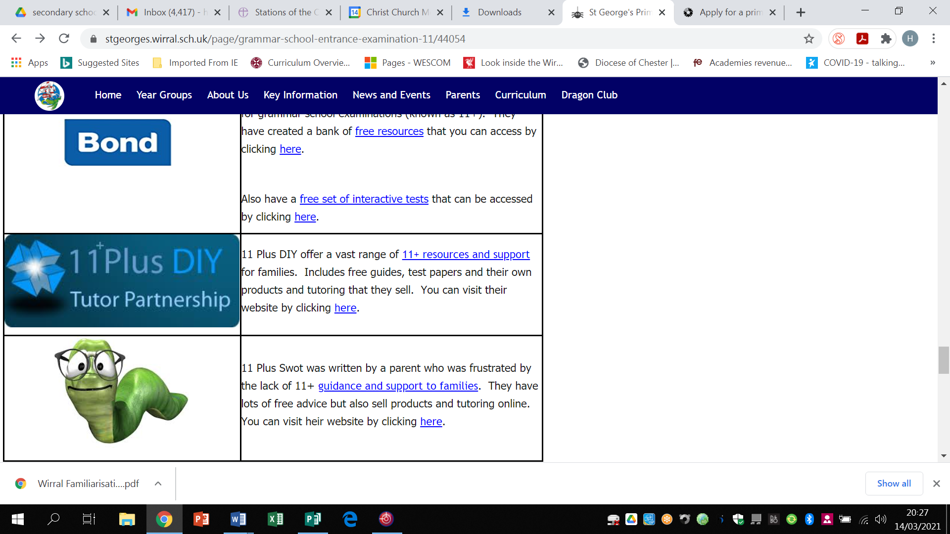 | Bond are a commercial supplier of resources to support tuition for grammar school examinations (known as 11+). They have created a bank of free resources that you can access by clicking here.  Also have a free set of interactive tests that can be accessed by clicking here.
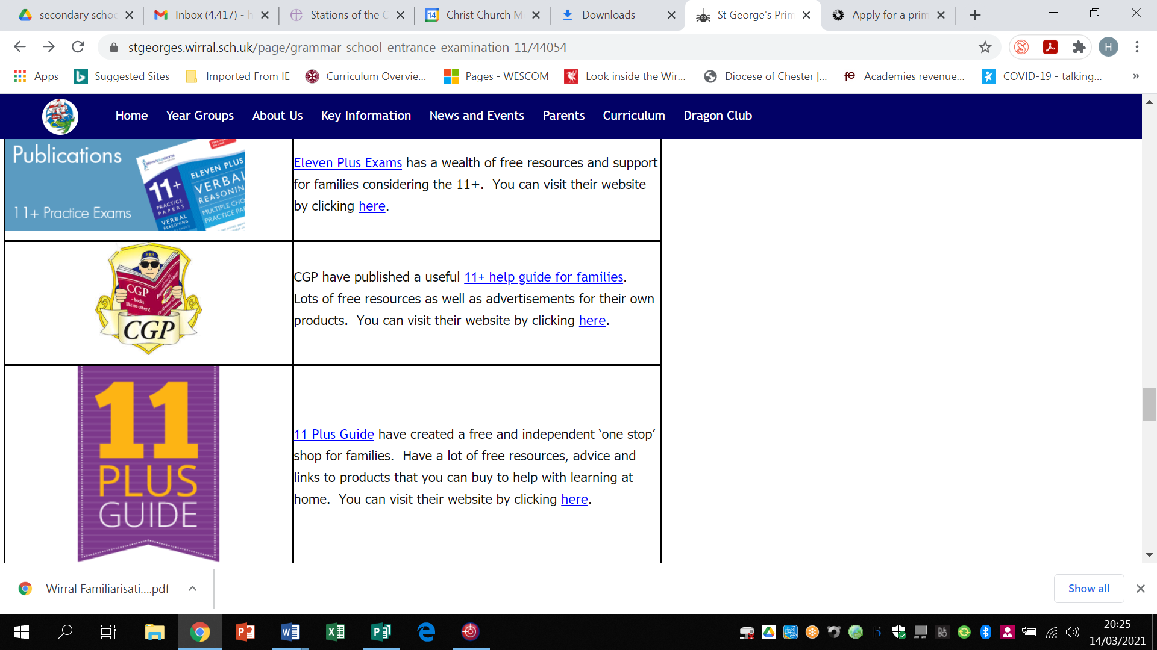 | Eleven Plus Exams have created a collection of free 11+ preparation guides and practice papers for families.  https://www.cgpbooks.co.uk/study-from-home  You can access them by clicking here.
 | CGP are a commercial supplier of resources to support tuition for grammar school examinations (known as 11+). They have created a bank of free resources that you can access by clicking here.
 | 11 Plus Guide is designed to be a one stop for families considering the 11+. They have compiled a helpful page of free resources to support your child. That can be read by clicking here.
Parents can also source high quality resources online, through apps and via publishers. These are good for familiarisation. Children should not be expected to work at test speed until September of the tests.
What Next?
I hope the information provided this evening along with our follow up discussions will answer any questions you may have and provide you with the information you need. The final page of linked resources are from a range of 11+ suppliers and the hyperlinks will take you to further resources that may be helpful.

I’m sure for many it will feel rather daunting, so my advice would be to talk together with your child, look at some of the sample material and if the 11+ is something you want to consider, set out a plan to work with your child to familiarise them with the materials. Starting with small amounts of time initially and then increasing over the coming months will help build your child’s confidence and then you can begin to work to timed sections as they become more familiar. Remember there are still six months before the test so regular, planned sessions will be of most benefit.

If there is anything further you’d like to know please contact the office and we will do our best to support you.

Best Wishes,

Mrs Donelan
Headteacher

School Entrance Tests | School Entrance Tests have a wealth of resources for families. Includes links to national example papers and information for families about entrance examinations. You can visit their website by clicking here.
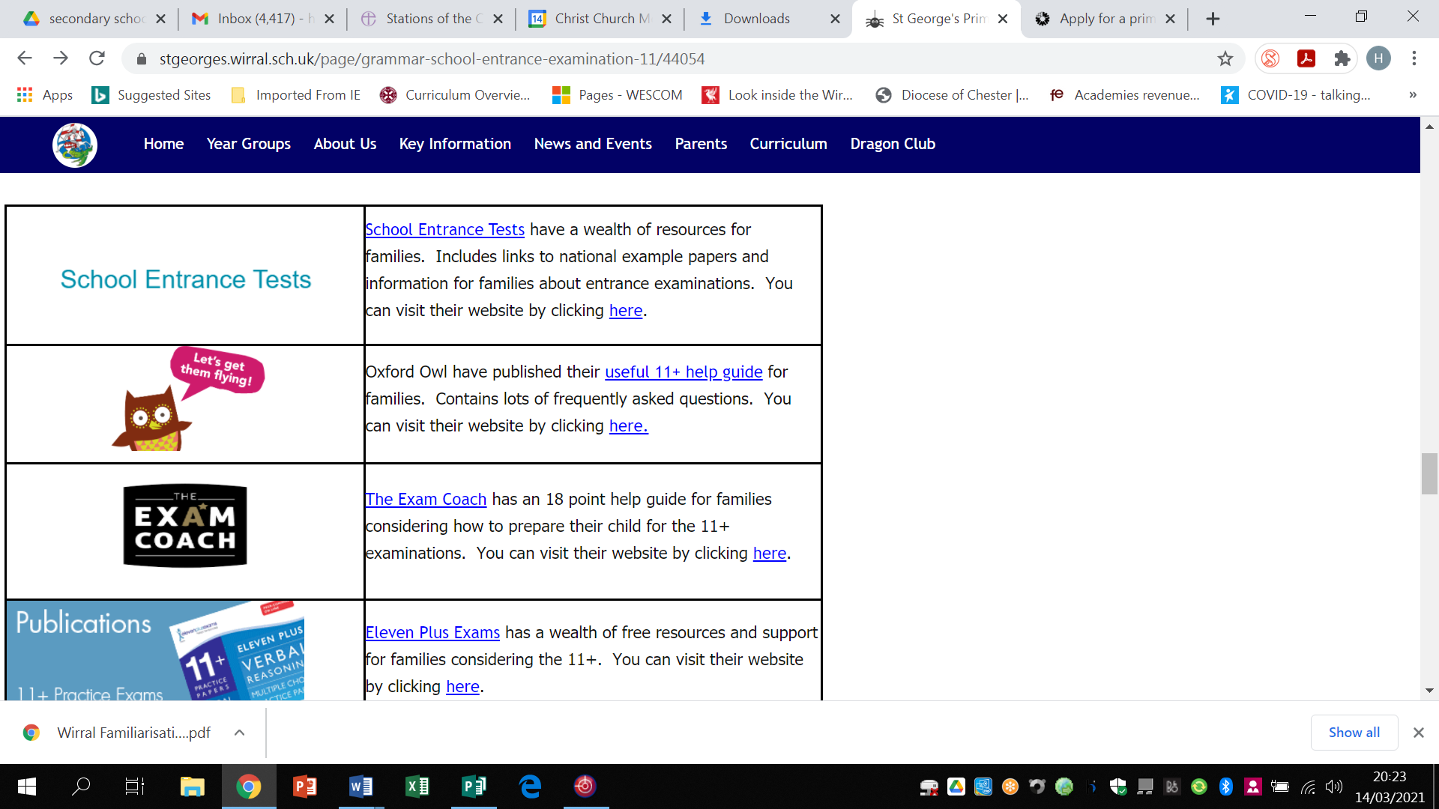 | Oxford Owl have published their useful 11+ help guide for families. Contains lots of frequently asked questions. You can visit their website by clicking here.
 | The Exam Coach has an 18 point help guide for families considering how to prepare their child for the 11+ examinations. You can visit their website by clicking here.
 | Eleven Plus Exams has a wealth of free resources and support for families considering the 11+. You can visit their website by clicking here.
 | CGP have published a useful 11+ help guide for families. Lots of free resources as well as advertisements for their own products. You can visit their website by clicking here.
 | 11 Plus Guide have created a free and independent ‘one stop’ shop for families. Have a lot of free resources, advice and links to products that you can buy to help with learning at home. You can visit their website by clicking here.
Bond are a commercial supplier of resources to support tuition for grammar school examinations (known as 11+). They have created a bank of free resources that you can access by clicking here.

Also have a free set of interactive tests that can be accessed by clicking here.
 | 11 Plus DIY offer a vast range of 11+ resources and support for families. Includes free guides, test papers and their own products and tutoring that they sell. You can visit their website by clicking here.
 | 11 Plus Swot was written by a parent who was frustrated by the lack of 11+ guidance and support to families. They have lots of free advice but also sell products and tutoring online. You can visit heir website by clicking here.

