
  Wirral Council
  Public Health
  Cheshire Lines Building
  6 Canning Street
  Birkenhead
  Wirral
  CH41 1AU
  www.wirral.gov.uk

Dear Parent / Carer,

We are now all learning to live safely with COVID-19. From 1st April 2022, the government has changed the rules on accessing tests for COVID-19. As a result of this, they have removed the current guidance for schools and replaced it with the more general guidance below:
https://www.gov.uk/guidance/people-with-symptoms-of-a-respiratory-infection-including-covid-19
As we move into this next phase, schools will continue with all of things they have been doing to reduce the spread of viruses (including COVID). These actions include making sure that busy places are well-ventilated and reinforcing good hygiene practices such as hand-washing and cleaning.
We would like to remind you of the key points from the updated government guidance so that you are clear about when your child should and should not attend school:
- It is no longer recommended that children and young people are routinely tested for COVID-19 (unless asked to by a health professional). If they do test positive however, they should not come into school and should try to stay at home for 3 days after the day they took the test. After 3 days, if they are well enough (and do not have an ongoing high temperature), they can return to school.

- Children and young people with mild symptoms such as a runny nose, sore throat, or slight cough, who are otherwise well, can continue to attend school.

- Children and young people who are unwell and have a high temperature should stay at home and avoid contact with other people, where they can. They can go back to school and resume normal activities when they no longer have a high temperature, and they are well enough to attend.

Through this next phase, we will continue to work with schools to support and advise them. If your child’s school has an outbreak, for example, they will be advised about additional actions they may need to take.
We would also like to remind you that vaccination is still the best way to keep everyone, including children and young people, safe. Please check the latest information on who can have a COVID-19 vaccination and how to get it here:
http://www.nhs.uk/conditions/coronavirus-covid-19/coronavirus-vaccination/
To book an appointment please visit https://www.nhs.uk/CovidVaccination or call 119.

Thank you for your support.
Yours Sincerely,

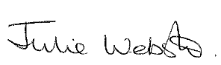
Julie Webster
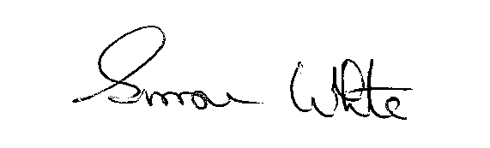
Director of Public Health

Simone White
Director of Children’s Services

