

**BEHAVIOUR POLICY**

This policy is informed by the Christian values which are the basis for all of CDAT's work and any actions taken under this policy will reflect this.

*‘Blessed are those who act justly, who always do what is right’*

*Psalm 106:3*

**Christ Church C of E Primary School Moreton**



|  |  |  |
| --- | --- | --- |
| Date agreed by LGB | Review Date | Signed Chair of LGB |
| September 2024 | September 2025 |  |

**Policy Process**

Our Mission Statement

Our mission is to love all children who are part of our community

helping them develop respect, tolerance, self-confidence and

to become the best they can be.

We will support our children to develop their God given gifts to the full

and encourage a life-long passion for learning

which will successfully lead them into secondary school and beyond.

As a church school at the heart of Moreton community,

our work is underpinned by the Christian values of

*friendship, humility, forgiveness, compassion, justice* and *service*

which Jesus helps us to achieve.

We are a welcoming, caring and inclusive school

committed to working in partnership with parents, governors, /

Christ Church and Chester Diocese Academy Trust.

We strive to provide a rich and varied curriculum

which reflects God’s concern for the whole child; promoting spiritual, moral,

cultural, physical and emotional wellbeing

alongside academic excellence and independence.

As a school community, we all work together

to provide the very best for our pupils and families;

firmly believing that:

**Together we can do all things through Christ who strengthens us**

Our School Vision

***Contributions from parents, pupils, staff and school Governors have determined the priorities for our school vision***

**A consistent school vision shared by all based on the following:**

“**Love must be completely sincere. Hate what is evil, hold on to what is good. Love one another warmly as Christians, and be eager to show respect for one another. Work hard and do not be lazy. Serve the Lord with a heart full of devotion. Let your hope keep you joyful, be patient in your troubles, and pray at all times.”** **Romans 12:9-12**

Contents

1. Introduction 5

2. Our Behaviour Principles

3. Approach 5

4. Expectations

5. Rewards 7

6. Sanctions 9

7. Code of conduct 10

8. Monitoring and Evaluation 12

9. Home/School/academy agreement 13

## Introduction

## CDAT’s first priority is the responsibility to safeguard and promote the welfare of all our students. As such, the Trust Board is charged with the duty to set the framework of the behaviour policies of each academy by providing a written statement of general principles relating to behaviour and discipline, taking into account the needs of all staff and students. These principles stem from CDAT’s clear, Christian vision: Rooted in Christian values, CDAT is committed to:

## • Valuing the uniqueness of every child

## • Aspiring to excellence

## • Being a nurturing learning community for all Jesus said, ‘I have come in order that you might have life—life in all its fullness’ (John 10:10).

## As a Trust, our aim is to ensure that all of our pupils are able to benefit from and enjoy ‘life in all its fullness.’

## Our Behaviour Principles

## CDAT’s Board believes that high standards of behaviour and attendance are important factors in a school’s success, allowing:

## • all pupils to make the best possible progress in all aspects of their educational life

## • all staff to teach and promote good learning.

## The Board fully supports the rights of all members of our school communities to work, learn and play in safe, supportive and stimulating environments. All members of the CDAT family are fully committed to working together to establish in each of our schools a positive ethos and promote effective learning within an environment where all children can feel safe, enjoy and achieve, be healthy, develop resilience and be prepared for the next stage of their educational journey.

## Behaviour should not jeopardise the health and safety of any member of the school community and all stakeholders are encouraged at all times to be positive role models.

## Naturally, where there are rights there are also responsibilities, and so we expect all members of each of our individual school communities to work together to:

## • uphold the Christian ethos of the school and Trust;

## • keep their school a safe place to be;

## • allow each other to learn;

## • treat each other with respect;

## • develop and maintain a positive, welcoming school community;

## • listen to each other

## • ensure that their school is a place where bullying is not tolerated, and where kindness is promoted

## The Trust’s Equalities Policy further confirms our determination to ensure that CDAT schools, and the broader trust itself, are inclusive places where members of the Trust’s community are able to work and learn, free from any form of discrimination, harassment or bullying (as laid down in the Equality Act, 2010.)

## Approach

The approach to managing behaviour may differ in individual academies, however, the basic expectation is that CDAT academies will take the following approach:

* to involve all of the School community in making and celebrating the rules
* to ensure that everyone knows and practises the core Christian values
* to regularly use a variety of strategies to promote high standards of behaviour
* to use praise to promote self-esteem, using this to reward kindness shown for others, for consistent good manners, good effort and high standards of achievement
* to ensure that all staff are conscious of the example they set the whole time
* to focus on the child’s behaviour and not the child him/herself
* to seek guidance from outside agencies when extra support is needed
* to take ownership of behaviour issues

It is important that each academy provides a clear and consistent approach to behaviour which can be adopted by staff, pupils and parents. All members of the community have the right to feel secure and well respected. Everyone is expected to show courtesy and tolerance for others and to behave in a responsible manner. The importance of training must be recognised, so that children gradually develop self-discipline and opportunities are provided for them to make independent choices and become increasingly responsible for their own actions.

## 4. Expectations

The following will be the basic behaviours expected of those involved in CDAT academies

|  |  |  |
| --- | --- | --- |
| **Staff, Governors, CDAT officers and Directors** | **Pupils** | **Parents** |
| * To lead by example * To be consistent in dealing with pupils * To encourage the aims and values of the school/academy and local community among the pupils * To have high expectations of the pupils * To meet the educational, social and behavioural needs of the pupils through an appropriate curriculum and individual support * To encourage regular communication between home and school | * To respect, support and care for each other both in school and the wider community * To listen to others and respect their opinions * To attend school regularly, on time, ready and equipped to learn and take part in School/academy activities * To take responsibility for their own actions and behaviour * To do as instructed by all members of staff (teaching and non-teaching) throughout the School day * To be tolerant of others, irrespective of race, gender, religion, age, ability/disability or sexuality. | * To be aware of and support the school/academy values and expectations * To support the school’s approach to behaviour management * To ensure that pupils come to school regularly, on time with the appropriate equipment * To provide the school with an explanation of the reasons for any absence as soon as possible * To take an active and supportive interest in their children’s work and progress * To keep up to date with school developments and share concerns where necessary |

**What does expected behaviour look like at Christ Church?**

**The role of teachers and staff**

* model appropriate, professional dress as stated in the school code of conduct
* use language that is fair and consistent in an appropriate tone that echoes and upholds our school values of love, service, peace, forgiveness, hope and joy to colleagues, pupils and visitors
* develop and maintain a calm and safe environment for all pupils which is neat, tidy and sets the correct tone for a purposeful learning atmosphere where pupils can be independent and ready to learn
* teach, model and encourage positive relationships rooted in our Christian values
* exhibit and uphold the expected behaviour of our school at all times when on/off site
* praise expected behaviour of pupils by immediately rewarding via our Class Charts system as well as distributing certificates and rewards in our weekly celebration service
* acknowledge that mistakes can be made by giving all pupils the chance to turn their unwanted behaviour around (amber zone)
* challenge any pupil across all parts of the school grounds who is not meeting our school expectations of acceptable conduct and remind/encourage how to correct it
* establish and maintain clear routines for beginning and ending the school day, walking around school as well as taking care of school equipment and furniture
* ensure that pupils move round school quietly, calmly and in an orderly fashion, reminding to respect those that are working in classrooms and offices as well as to be mindful of their younger counterparts
* explicitly teach and reinforce the school code of conduct and refer to it often as expected behaviours of Christ Church
* follow through the behaviour policy for rewards as well as consequences
* ensure that all pupils, regardless of need can succeed in their behaviour by providing an environment where all learners can achieve
* identify and anticipate likely triggers for pupils who need support with concentration; adjust seating plans as well as provide movement breaks, resistance bands, fidget objects and other sensory resources that may help to reduce sensory overload and improve attention
* seek advice from SEMH lead (Rachel Parrington) and/or SENDCO (Jenny Thornton) for support with pupils struggling with managing their behaviour
* attend relevant training for behaviour management as well as SEND

**The role of pupils**

* follow and uphold the school rules as displayed on our school code of conduct
* respect every member of our school community through their language, tone, conduct and behaviour online as well as out of school
* understand that every pupil deserves the right to learn in an environment that is calm, safe, supportive and where they are treated with dignity
* show respect to all members of staff by following instructions and adhering to rules and routines
* live out our school values of love, service, peace, forgiveness, hope and joy every day and aim to find ways to show these values to others
* contribute to our school ethos and culture by actively participating in lessons as well as showing kindness and compassion to others in, out and around school
* accept consequences for unwanted behaviour and aim to improve behaviour going forward
* move around school safely and calmly, respecting others who may be working as well as younger children in and around school
* respect and take care of school equipment, books and furniture
* complete homework on time and ask their teacher if support is required

**The role of parents**

* understand and support the school’s behaviour policy as well as our values and vision
* reinforce our code of conduct by encouraging their child(ren) to adhere to the school rules and routines
* raise concerns re. behaviour management directly with the school so that any issues can be immediately addressed
* support the school’s system of rewards and consequences
* model appropriate communication to members of staff so that pupils can view parents and school working together in a respectful manner
* ensure that their child(ren) attends school regularly and on time with the correct equipment and uniform
* encourage and facilitate the completion of their child’s homework
* attend parent-teacher meetings
* monitor their child’s online habits to ensure internet safety is being upheld as well as appropriate apps/sites are being used in line with recommended age restrictions
* refrain from posting defamatory content on social media about other parents, pupils, the school or its employees as well as any content containing confidential information regarding the school or members of its community (see Social Media Code of Conduct for Parents and Carers)

Whilst Christ Church is an inclusive school, the safety of our children, staff and families is our main priority. If children do not follow the expectations listed above, despite reasonable adjustments and they do not comply with the protocol to keep themselves and others safe then:

* A member of staff in charge of the class will have a quiet word to redirect the pupil to make a positive behaviour choice.
* If the undesirable behaviour continues, the child’s name will be written on an ‘amber zone’ displayed in the classroom. The pupil is then given an opportunity to reflect and change their behaviour. Their name can then be erased if the pupil turns their behaviour around.
* If the undesirable behaviour continues, the pupil will be awarded a negative point.
* Should this continue then they will be removed from the class setting to a previously arranged member of staff for time to reflect
* Should this continue then their parent/ carers will be consulted to support
* The child will be sent home (SLT decision) if the unwanted behaviours continue

## 5. Rewards

CDAT is clear that the emphasis is on rewards to reinforce good behaviour, rather than on failures. CDAT believes that rewards have a motivational role, helping students to see that good behaviour is valued. The commonest reward is praise, informal and formal, public and private, to individuals and groups. It is earned by the maintenance of good standards of behaviour as well as by particularly noteworthy achievements. This is as true for adults as for students.

At Christ Church, the following rewards system is in place:

Class Charts Across the School

We use a system called Class Charts which is an online system to log behaviour incidents and to add rewards. This system enables students to be rewarded for all aspects of their school life, visually seeing the progress and being able to interact with this online through an APP. Parents can also download an APP, which allows them to track their child’s rewards and behaviours.

Class Charts allows staff to award children with positive points for achievements in academics, citizenship and general kindness and respect. As children acquire points they receive class tokens/awards. For every 100 points the children receive a certificate and a star badge for their achievements. Green/positive points are awarded for the following:

: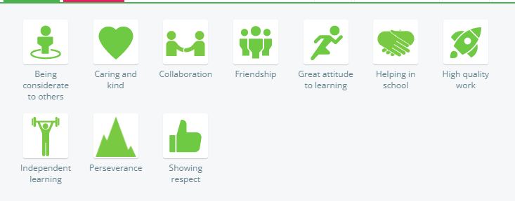

**Class Charts Reward Certificates**

|  |  |  |  |
| --- | --- | --- | --- |
| **Number of Points** | **Award** | **Number of Points** | **Award** |
| 100 | Bronze | 800 | Sapphire |
| 200 | Silver | 900 | Opal |
| 300 | Gold | 1000 | Amethyst |
| 400 | Platinum | 1100 | Citrine |
| 500 | Titanium | 1200 | Turquoise |
| 600 | Emerald | 1300 | Amber |
| 700 | Ruby | 1400 | Peridot |

**Star of the Week**

Star of the Week certificates will be awarded to 2 children from each class every week and will be recognised in Celebration Assemblies. These certificates will be a surprise to the children and can be awarded for any individual achievement.



**House Teams**

Christ Church have four teams, named after mountains: Kilimanjaro, Snowdon, Everest and Mount Blanc. These teams are used for organisational purposes, for example groupings on Sports Days.

Each team has a colour which is then reflected in the pupils’ coloured t-shirts as part of the school PE kit.

**Kindness Captains**

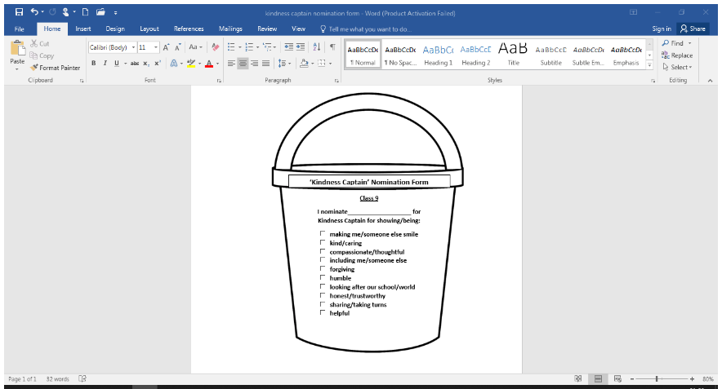 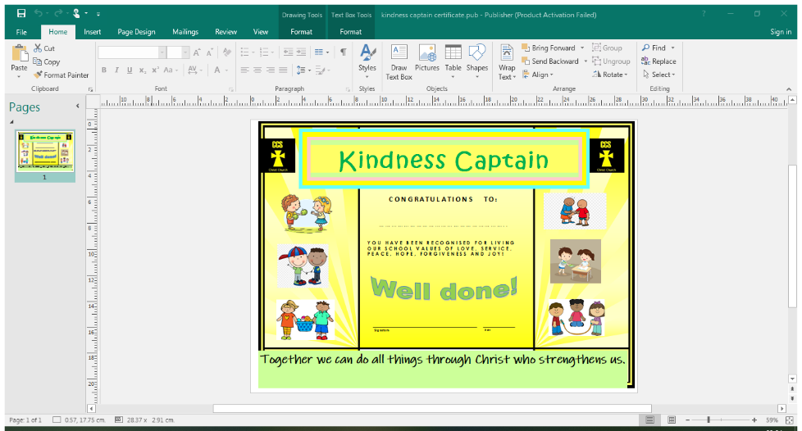 

At Christ Church, we have recently introduced a new reward: the ***Kindness Captain***. Each class has a bucket displayed in their classroom where the goal is to fill the bucket with nomination forms from children and staff. Children will get nominated for living out our Christian values of ***respect, patience, love, hope, service and joy.*** Each class has discussed and agreed upon what it looks like to show these values within showing kindness and the qualities/values of somebody who might be given a kindness award

Teachers will then choose a kindness captain each week in readiness for celebration service. Kindness Captains will be presented with a yellow, satin sash (FS2-Y4) or an armband (Y5/6) to wear in school and at home the following week as well as a certificate. The previous captain will then pass up their sash/armband to their successor in the next celebration assembly.

**Awesome Alert!**

   

Each week, staff will communicate to at least one family of a child from their class who has been awesome! This child(ren) will be somebody who has shone in some way and impressed their teacher. This might be a child who has gone above and beyond with their learning, homework, attitude or citizenship in school. This alert could be via a face-to-face chat at the end of the day/ a postcard home/ an email or a telephone call home. We believe that celebrating children’s achievements in this way is a real boost to the child’s self-esteem and builds relationships with families too.

## 6. Sanctions

Although rewards are central to the encouragement of good behaviour, realistically there is a need for sanctions to register the disapproval of unacceptable behaviour and to protect the security and stability of the Christ Church community. In an environment where respect is central, it is an expectation for children to follow the school rules and for parents to be informed of a breach of these rules via Class Charts. Any significant breach or serious, negative behaviour: parents will be contacted personally by school to discuss and find ways forward.

The ethos of Christ Church teaches children that everyone makes mistakes, yet forgiveness is important and everyone deserve compassion and understanding. There are times when children make a wrong choice and are receive a negative point. At Christ Church we are always discussing how children can put a mistake right and the importance of forgiveness. It is important to note that all children are given a warning prior to receiving a negative point and have the opportunity to change their behaviour and rectify any mistakes.

**Negative/Red points:**

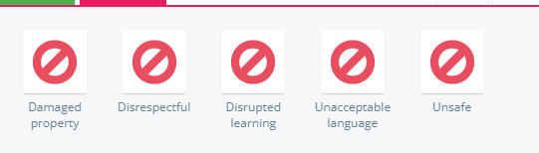

Rewards and Sanctions can be added and changed throughout the year based on the needs of the children and with staff collaboration. If a child’s individual needs are such that they are unable to follow Class Charts, an individual programme can be made with support of class teacher, children, parent, team leader and SENDCO as needed.

The use of sanctions should be characterised by certain features:

* It is clear why the sanction is being applied.
* It is clear what changes in behaviour are required to avoid future punishment.
* Group punishment should be avoided.
* There is a clear distinction between minor and major offences.
* It is the behaviour rather than the person that is punished.
* Any discussion with children relating to behaviour incidents should be carried out in a quiet, calm and non-confrontational manner.

The following sanctions are permitted for use in CDAT Academies:

* Non -verbal warnings.
* Informal verbal warning that is not recorded.
* Formal verbal warning that is recorded and this will be recorded.
* Time out in the classroom.
* Time out outside the classroom environment supervised by another member of staff.
* Letter home to parents.
* Separate supervision during break or lunchtime.
* The loss of privileges.

In extreme circumstances Fixed or Permanent exclusions will be considered in line with the Exclusions Policy.

## 7. Code of conduct

Each CDAT academy will have ‘School/academy rules’ or ‘code of conduct’ drawn up in consultation with staff and children and based on this policy.

Each classroom and communal space has the school Code of Conduct displayed and it has been agreed to by all staff, pupils and parents via the Home-School Agreement.

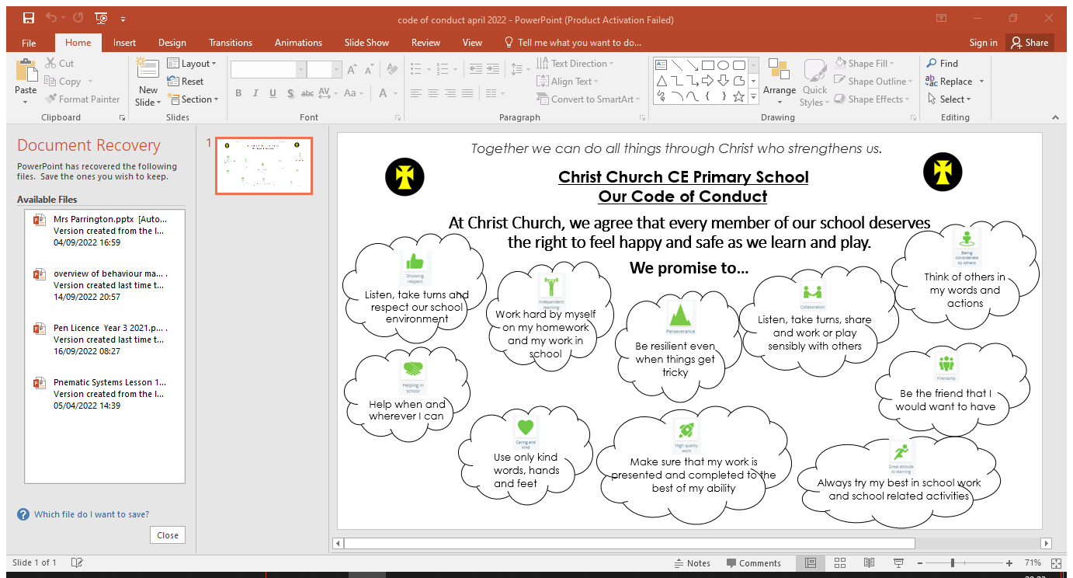

**Behaviour Management in our Pre-School Provision**

Class charts will be adapted for our Pre-School. Visuals of each class chart promise will be displayed so that our youngest pupils can recognise these from our code of conduct. Staff will use the same language of green/positive point, however will reward these instantly with green smiley face stickers for the child to proudly display on their uniform. Children will go home with all of the green ‘points’ they have earned that day in the form of stickers.

Staff will adopt natural consequences as a result of an incident to support teaching children ways forward. If necessary, staff may spend time with a child 1:1 in Continuous Provision to reflect on an action. Staff will discuss with parents at the end of the school day to work together on supporting their child.

**Behaviour and Conduct at Lunchtime and in Breakfast and After School Club**

All staff work to the same policies across the school. Staff working during lunchtimes and in our extended care (CC4C) will follow this policy. Our Breakfast and After School Club will adopt our positive ethos by rewarding children with green points and will follow the sanctions outlined in the policy.

**Vulnerable Pupils**

During their time at school some pupils will require extra support in managing their behaviour. At these times the behaviour strategy may need to be adapted to support vulnerable pupils. The behaviour tracking system will be reviewed by the class teacher, SLT and SENDCO to get an overview of the pupil progress. This will enable targeting support for vulnerable pupils.

This information will contribute towards:

* Individual Education and/or Behaviour Plans
* Pastoral Support Programmes

**Safeguarding**

Children’s behaviour may raise safeguarding concerns. Staff should record and report these to the head teacher as the school’s designated child protection officer. All staff receive training on the link between behaviours and possible issues relating to safeguarding.

**The Prevention of Inappropriate Behaviour**

Inappropriate or unacceptable behaviour is dealt with at the time by the supervising adult. Persistent, poor behaviour can be referred to a senior member of staff within the child’s key stage or year band. These referrals are at the discretion of members of staff who use their experience and professional judgement to decide upon appropriate action.

Parents are involved from an early stage. Initially this involvement is limited to an informal conversation with the class teacher, but continuation of the inappropriate behaviour can result in parents discussing the problem with a senior member of staff.

There is an agreed system of sanctions within the school. These are used to discourage and correct unacceptable behaviour, and are applied according to the level of seriousness of the problem. The following sanctions may be used alongside the constant recognition and reinforcement of good behaviour:

* One, discrete, verbal reminder followed by name on the amber zone
* Negative point added to Class Charts
* Thinking time / time out (EYFS/KS1)
* Removal from the class / group (previously arranged member of staff)
* Part/whole missed next playtime (KS2)
* Discussion with class teacher and parent / carer
* Home school book instigated / or internal behaviour incident log
* Discussion with senior staff and parent / carer
* Referral to external agencies

When escalating a behaviour incident to SLT, the following tiered system is in place:

* (EYFS: B.Campbell), (KS1: M Hogg) (LKS2: R.Parrington), UKS2 (C Cooper)
* Deputy Headteacher (L.Grant-Jones)
* Head-Teacher (A.Donelan)

**Behaviour Escalation System**

Please find below the escalation system for pupils in our school. These are displayed around school; in classrooms and communal areas so that all members of the school community are aware of procedures to ensure consistency and parity.

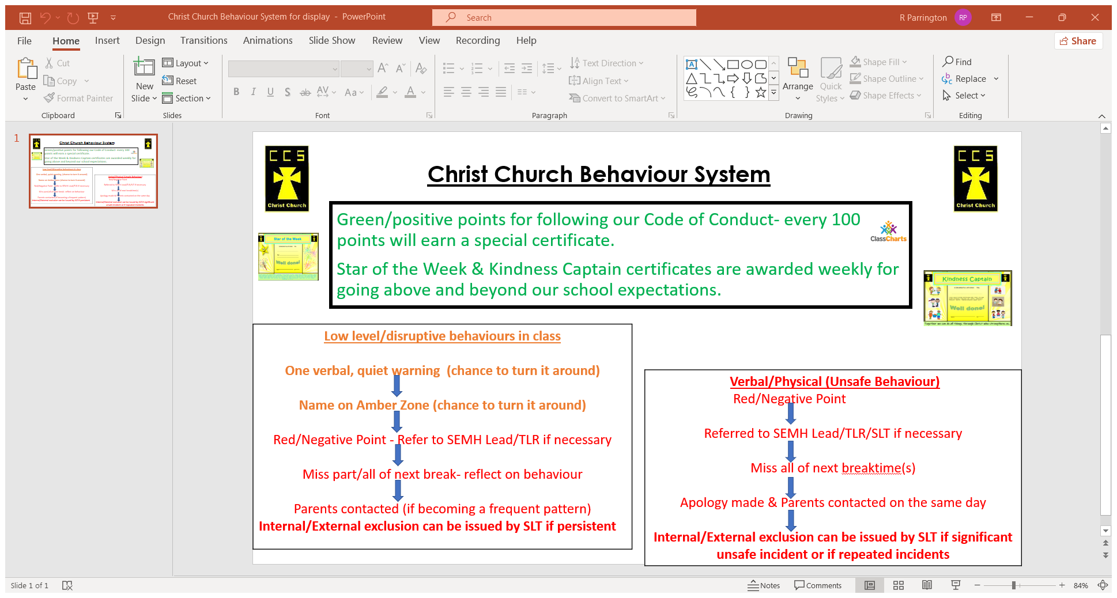

If a child displays a consistent improvement in effort or behaviour, from a previously unacceptable standard, the class teacher may refer him/her to:

1. Other member of staff (previously arranged)/Behaviour Lead
2. Key Stage leader (TLR)
3. Deputy Head teacher
4. the Headteacher

to be given verbal praise and encouragement to continue the effort.

In a Christian school such as Christ Church C.E. Primary School, it is important for forgiveness to be shown. This is not to say that inappropriate behaviour is to be condoned or allowed to go without consequence, but rather that the child should realise that he/she can be forgiven and that no grudges are held. Every day is a new start for every child to have the opportunity to succeed.

Restorative practice takes place following a lunchtime break so that pupils can feel heard and a sense of justice has prevailed. A teacher from the year group will sit and listen to the children to mediate a conversation as well as to support pupils to accept and take responsibility for their part in the conflict. Children will then be part of the decision process of apologies and consequences (following the behaviour escalation system). Ultimately, staff will have the final decision upon consequences. Where appropriate, pupils can complete a Restorative Practice proforma to guide the children’s reflections on what has happened.

Violent Behaviour and Verbal Abuse

Violent Behaviour is classified as intentional physical behaviour that hurts another child or adult. Verbal abuse is classified as intentional inappropriate language that is deemed to be abusive towards another child or adult. If a child displays any of the above behaviour a member of the Management Team will decide upon the appropriate course of action. Parents / Carers will be informed if an incident of this type occurs. If the incident is deemed to be particularly severe, the Management member of staff will report this to the SLT who will arrange a meeting with a parent. Violent behaviour can result in an **exclusion** from school or an activity either internally or externally. In the instance of a pupil being excluded, the school will provide work for the pupil to complete so that they do not lose learning time or fall behind their peers.

Bullying

At Christ Church C.E. Primary School we are aware, and accept, that bullying is a potential problem in this and every school. Bullying can involve physical or verbal attacks or other forms of aggression, over a period of time. If bullying happened to an adult it would be called “harassment “or “assault”.

By promoting a climate of positive relationships of care and mutual respect, children are encouraged, if bullying occurs, to regard “telling” as acceptable and responsible.

Attending to reports of bullying is regarded as a priority by all members of staff, and support will be given to the victim. As with all inappropriate behaviour, sanctions will be applied to the aggressor.

Bullying in any form will not be tolerated at Christ Church C.E. Primary School. Please refer to the school’s Anti-Bullying Policy.

Disciplining Beyond the School gates

School will consider sanctions for disruptive behaviour outside school. This will be implemented in all issues when a child’s behaviour risks the safety or well-being of any member of our community. This could include another pupil; a member of staff or any other member of our school community. The school will also seek to apply sanctions or behaviour support if it felt that a child’s behaviour is anti-social or affects the reputation of the school and is not in line with the whole school ethos.

These decisions will be taken by the head teacher on a case by case basis.

**Curriculum Integration**

Aspects of pupil behaviour, including how we should relate to one another, are covered within the school curriculum, in subjects such as Religious Education and Personal, Social and Health Education and Citizenship. Expected conduct is regularly reviewed through assemblies and in the classroom. Our values and behaviour expectations are visited through collective worship with the head teacher, clergy, Deputy Headteacher, class teachers and Vision Voyagers.

**Managing Pupil Transition**

Children transitioning from Year 6 to Year 7 will receive an enhanced transition alongside additional information and an informed handover from the school SENCO.

## 

## 8. Monitoring and Evaluation

Rewards and all sanctions more serious than informal verbal warnings will be recorded and monitored to provide the Local Governing Body and CDAT with regular information on how effectively the behaviour policy is working. The academy will also monitor to ensure that rewards and sanctions are distributed fairly and so the data will be analysed by:

* + Gender
  + Ethnicity
  + SEN
  + Age

The Headteacher monitors the effectiveness of this policy on a regular basis. She also reports to the governing body on the effectiveness of the policy and, if necessary, makes recommendations for further improvements.

Class teachers monitor procedures in their classes and report to their Key Stage / team leaders.

The school keeps a record of incidents. The Headteacher records those incidents where a child is sent to them on account of challenging behaviour. The Midday Supervisors report any incidents to the class teachers who decide if the Headteacher or Assistant Headteachers should be informed and a record made.

The Headteacher keeps a record of any pupil who is excluded for a fixed term or who is permanently excluded.

It is the responsibility of the governing body to monitor the rate of fixed term exclusions and permanent exclusions, and to ensure that the school policy is administered fairly and consistently.

## 

## 9. Home/School/academy agreement

The Home/School/academy agreement will be based on this policy and have the Christian ethos as its basis.

Every parent is expected to the sign the Home/School/academy agreement when their child starts Christ Church as an indication of the partnership between home and School. This will be reviewed and re-issued to parents annually to remind them and their children of its importance.