Key texts
Running Wild – Michael Morpurgo
Natural Disasters – Non – fiction text.

Enrichments
Planting trees/ litter picking project within the local community.
.
Plan an environmentally friendly menu.

Extreme Earth: How has our planet changed?

How has our planet changed?

 | Word of the week Summer 1 Summer 2
Week 1 | Week 2 |  | Week 3 |  | Week 4 | Week 5 |  | Week 6 |  | Week 7
Baseline | muscle | interrupt |  | stomach |  |  | embarrass |  | necessary |  | profit/prophet
Baseline | conscience | bruise |  | neighbour |  |  | definite |  | determined |  | cereal/serial

 | What will I know? | How will I learn it? | Vocabulary
History  (Social Justice)  How has our planet changed? | Confident use of library, e-learning  Compare accounts of natural disasters that have occurred from different sources.  Offer some reasons for different versions of events.  Select relevant sections of information. | What are the biggest natural disasters in world history? (chronology) Children to create a timeline of the world’s famous natural disasters.  How do natural disasters affect people? (curiosity- explanation text) Research a type of natural disaster end explore how it has affected local people. Children to create an explanation text on the event.  What are the similarities and difference between these two natural disasters? (Comparison of past event and modern event and the difference in support) Explore a past natural disaster (e.g Vesuvius), compare to a modern day event, and explore the difference in support given.  What can we do to prevent climate change? (project based and present to younger children) Children to discuss climate change and think about their impact on their immediate environment. Children to research and produce an information piece on how we can prevent climate change. | Environment, cause and effect, physical and human features, disaster, earthquakes, hurricanes, tsunami, volcanic eruptions, cause, effects, reform, consequences, primary evidence, secondary evidence.
Geography | Understand and use a widening range of geographical terms e.g. specific vocabulary – climate zones, biomes and vegetation belts, rivers, mountains, volcanoes and earthquakes, and the water cycle  Recognise the different shapes of countries.  Identify the physical characteristics and key topographical features of the countries within North America.  Understand how humans affect the environment over time.  Know about changes to the world environments over time.  Compare the physical and human features of a region of the UK and a region of North America, identifying similarities and differences. | What are the world biomes? (physical geography) (VR on biomes (field work) – Look at a world map and explore different biomes through VR. Label a world map with the different biomes/climate zones.  Where is North America? (mapping)  Look at the map of North America: label the different biomes in North America. Each learning partner to research a specific biome and present as a two-page spread/information booklet.  What is climate change and how does it affect the Earth? (human geography)  Research climate change and create a poster detailing what is climate change.  What are the similarities and differences between the North of America and the UK? (VR goggles, virtual tours) (place knowledge and field work) Take a virtual tour through North America and the UK. Discuss the similarities and differences of North America and UK looking at time zones, climate and weather. Present findings in a two-page spread. | Climate zones, biomes, vegetation belts, rivers, mountains, volcanoes, earthquakes, water cycle. North America, countries, shapes, environment, cause and effect, physical and human features, region, differences, similarities, Savannah, grasslands, salt water, freshwater, boreal, tundra, rainforest.
Art / DT | Focus: Design Technology- Cookery/ 3D Sculpture Structures.  Focus: Printing / digital media/painting  Focus: Artist John Dyer | Recycled material animals using wire sculpture.  Environmentally friendly food.  Climate change abstract art –mixed media using their imagination depicting the effect of climate change on the world today  (tree of extinction) / David Ambarzumjan | sculpture, structure, assemble, construct, model, cut, stick, fold, bend, attach, assemble, statue, stone, shell, wood, metal, curve, form, clay, impress, texture, viewpoint, detail, decoration, natural, two dimensional, three dimensional, tiles, brick, slate, bronze, iron, composition, profile, stylised, proportion, ornate, symbolic, perspective, realistic, surface texture, balance, transform, relationship, movement, rhythm, flexible, pliable, hollow, solid, plane, angle, slip, attachment, relief cut, paste, ipad, programme, move, tool, enlarge, scale, stamp, magic wand, clone, layer, layer palette, overlay, transparent, green screen, hue, saturation, enhance, opacity, translucence, merge, architecture, structure, detail, text box, style
Computing | CS5/6.10 To use simulation software to create realistic or fantasy representations of the real world  CS5/6.10 To use modelling and simulation software to create realistic or fantasy representations of the real world  - DL5/6.6 To be able to use graphs to provide supporting evidence for their conclusions  - DL5/6.7 To be able to check for accuracy by checking data and looking at graphs  - DL5/6.23 Add formula to spreadsheets , enter data and use filters to sort information  DL5/6.24 Add data validation e.g drop down lists and conditional formatting to spreadsheets  - Chn should understand that computer data is stored in binary form (1s and 0s) and that there are 8 bits in a byte  - Chn to understand that devices must agree on security, speed and style of connection before they can transmit data. THis is called the handshake signal  - Data is sent in packets to help with cyber security and error correction  DL5/6.17 To be able to initiate and take part in collaborative learning using a variety of methods e.g. survey  Coding: | To create a simulation-Hurricane tracking  Research the amount of hurricanes in different states, sort information into regions, use formulas like sum and average, export as graph to illustrate where the most affected areas are.  Children learn about networks and the internet and website design.  At the end of each unit, children create a Google Forms quiz for their friends to complete. Data from this could be used in other projects.  Events in bounce. | Simulation, software. Representations, graphs, conclusions, accuracy, data, formula, spreadsheet, filters, information, region, sum and average, excel, binary form, byte, networks, internet, website, design, connection, speed, devices, survey,
Music | Performing  Play melodies on tuned percussion, melodic instruments or keyboards, following staff notation (note range C–C /do–do)  Understand how triads are formed, and play them on tuned percussion / melodic instruments.  Perform simple, chordal accompaniments to familiar songs (e.g. Yellow Submarine by The Beatles). G major / D major.  Develop the skill of playing by ear on tuned instruments, copying longer phrases and familiar melodies. | Use percussion instruments and knowledge from previous units and composing unit in last term to perfom melodies.  Learn and rehearse a song of choice to perform for other year groups in school and parents. | Pitch, tone, rhythm, beat, tempo, melody, percussion, keys, notation, triad, melody, accompaniment, phrases.
Science | Living things and their habitats:  Describe the differences in the life cycles of a mammal, an amphibian, an insect and a bird  Describe the life process of reproduction in some plants and animals.  Animals Including humans:  Describe the changes as humans develop to old age | Weekly 1hr 30 lessons for Science  Assessment on prior learning in Autumn 1  Vocabulary check list  Using science snapshots to recap/explain what the children have learned weekly at the beginning of a science lesson.  Comparing life cycles of different animals w.s –  Develop an understanding about reproduction in different animals. Describe the differences between the life cycles of mammals and amphibians, insect and a bird.  Describe reproduction in flowering and non-flowering plants  Develop an understanding about reproduction in flowering and non-flowering plants.  Naturalist Research –  Develop an understanding of what is a naturalist and recognise influential naturalist and the important work they do. Present research as an information poster.  Life Cycle of a human –  Develop an understanding of the life cycle of a human and the changes. Recognise and describe the stages we go through as a human.  Gestation periods of animals:  Recall the gestation periods of different animals and make comparisons. Record and conclude findings. | Life cycle, mammals, amphibians, insects, bird, reproduction, plants, animals, naturalist, human, stages. Gestation, record, conclusion, baby, toddler, child, teenager, adults, adolescent, puberty, offspring, reproduce, sexual, sperm, fertilises, egg, live young, asexual, metamorphosis, plantlets, runners, bulbs, cuttings.

 | What will I know? |  | How will I learn it?
Maths sequences | 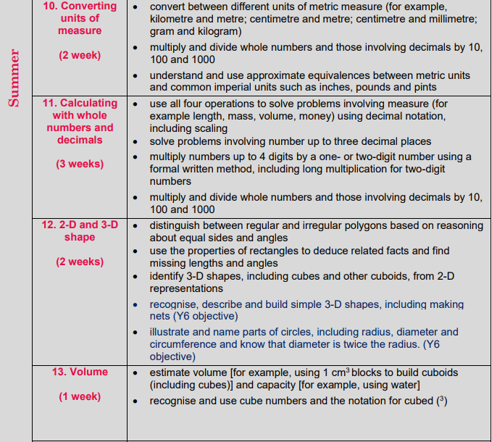  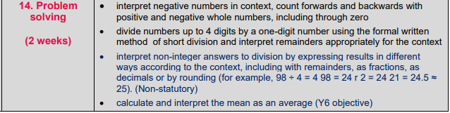 |  | Maths Mastery Lessons  Fluency practise  Mental maths/Year 6 ready lesson – once a week.
 |  |  | Mental methods taught from Year 5 progression document –then practise through daily fluency sessions.
English sequences | GPAS | Commas to clarify meaning and avoid ambiguity  Cohesion – adverbials of time Devices to build cohesion within a paragraph [for example, then, after that, this, firstly] Link ideas across paragraphs using adverbials of time [for example, later], place [for example, nearby] and number [for example, secondly] or tense choices [for example, he had seen her before]  Prefixes – dis – de- mis- over – and re –  Suffixes – converting nounr or adjectives into verbs using - ate, - ise, - ify | Weekly discrete lesson for grammar.
 | Reading | VIPER questions once a week.  Reading for pleasure  1:1 Reading  Whole class read for English | Once a week  Daily timetabled reading sessions  Once a week  Daily reading session
 | Writing | To write a prediction of the cover  To write a non-chronological report  To write an informal letter  To write a setting description  To write a survival guide  To write a blog  To write from an alternative character’s perspective
 | Vocab/Spelling | Teaching of scode spelling scheme, baseline test and follow up test. | Using the ppt and worksheets - 20 minute lesson, 4 times a week.

