Key texts
Percy Jackson and the lightning thief

Medieval Medicine
How did disease spread in Medieval times?
Enrichments
Sick to Death Museum visit – Nov 2022.
A day in the life of a medieval person – December 2022.
Bikeabiity – Level 2 cycling proficiency course.

 | Word of the week Autumn 1 Autumn 2
Week 1 | Week 2 |  | Week 3 |  | Week 4 | Week 5 |  | Week 6 |  | Week 7
Baseline | profession | fundamental |  | sacrifice |  |  | sufficient and deficient |  | triumph |  | physical
Baseline | government | environment |  | father |  |  | Parliament |  | ancient |  | ghoul

 | What will I know? | How will I learn it? | Vocabulary
History | To place current studies on a time line, know and sequence key events of time studied, use relevant terms and period labels.  Make comparisons between different times in history.  Compare accounts from different sources.  Use evidence to build-up a picture of life in time studied.  Confident use of library, e-learning and research.  Begin to identify primary and secondary sources. | Where does the bubonic plague fit in our timeline of events? Create a timeline labelling the main periods of time. Create a ‘zoomed’ in time line of the key events in Medieval Times e.g bubonic plague, medicines were discovered etc.  What were the main medicines used during the medieval period? Two page spread of main beliefs about illness and disease in medieval times and the methods of curing these illnesses. Sick to Death Museum visit will also support this – follow up lesson on this following visit.  What was the bubonic plague/black death and what caused it?  Research what it was, where it came from, beliefs about the causes and approaches to treatment using secondary sources (books and internet).  How can we compare the spread of disease in Medieval times to modern day Britain?  Complete a case study of COVID19 and compare similarities and differences with the black death – include treatment, prevention, changes to law etc..  Key Question: How did disease spread in Medieval times?  Contrary to the belief about God sending disease/illness e.g. the Black Death, explain how trade routes such as the silk Road and Spice routes enabled not only goods to travel around the world, but also disease. | Contagion, disease, death, plague, bubonic plague (1348), , conspiracy theory, pandemic, myth, legend, fable, bleeding, purging, the four humours, trepanning, leeches, herbs, buboes, vomit, diahoerra, baths, praying, smoke, whip, treatment, prevention, quarantine, covid19, lockdown, isolation.
Geography | Know about the wider context of places e.g county, region, country.  Know and locate the capital cities of countries in the British Isles and Uk, seas around the Uk, European countries with high poplations and large areas and the largest cities in each continent. | What were the main trade routes in Medieval times? – Look at maps of The Silk Road and other trade routes (Spice Routes) around the world. Complete map work to show these by labelling countries, regions and capital cities across the world and Europe and then into the UK - seperately.  How did disease spread in Medieval Europe?  Investigate how and why the black plague was able to spread from Asia to Europe through these trade routes and then on to the UK. Draw a timeline of events that shows this and locate countries and cities affected on a map.  How did disease spread in Medieval Britain?  Focus on the UK specifically – counties and regions most affected by disease and the black plague. Label capital cities and counties of the british isles and look at the spread of the disease across the population, highlighting most affected areas and why this was the case.  What was the importance of coastlines in Medieval times?  Look at the physical features of coasts and how other maritme routes (Spice Routes) were used for trade and travel. Understand the physical and human features of coasts and locate the main ones within the UK at this time – Bristol was one of the busiest ports in Europe at that time. | Continent, country, county, region, city, British Isles, Britain, UK, Europe, Asia, Constantinople, Italy, Silk Road, Spice Route, maritime, contagion, disease, population, atlas, map, spread, trade, route, characteristic, seas, coastline, port.
Art / DT | Theme: Medieval Medicine  Focus: Collage  Focus: DT – structures  Focus: Drawing  Focus artist/designer –  Craft Makers: | Drawing an illuminated letter and embellish using collage.  Recreating a scaled model of a medieval house considering proportion and style. Research the houses of the time, look at materials that were used, plan design for their own house.  Medieval dragon drawings using pencils, tone, shades.  Christian works of art through history.  Illumination artists. | Embellish, scale, collage, drawing, illuminated, materials, thick, thin, soft, broad, narrow, fine, pattern, line, shape, detail, mirror image, natural, man-made, environment, comparison, still life, observation, charcoal, coloured pencil, drawing pencil, felt tip pen, marker, frame, position, boundary, label, line, symbol, practical, impractical, change, improve, plan, distance, direction, weight, pressure, portrait, past, present, appearance, character, personality, viewpoint, angle, perspective, bird’s eye view, alter, modify, interior, exterior, vista, panorama, image, subject, caricature, expression
Computing | E-safety  -How to use social media  -Understand the code of conduct for online collaboration  -Understand what to do in the case of cyber-bullying  Coding:  Think logically that when x happens y is the result and show this using code, flowcharts, diagrams or explanations.  Use “say” commands to give information.  Test and debug regularly.  Program and explain what happens when more than one variable changes.  Know when to use “repeat", "repeat until" and "forever if" loops to make programs shorter and more efficient and be able to use them (understanding the differences between them).  Understand what 'events' are and use them efficiently within programs to start and stop scripts.  DL5/6.17 To be able to initiate and take part in collaborative learning using a variety of methods e.g. survey | Weekly computing lessons using https://www.commonsense.org/education/digital-citizenship/curriculum  Weekly lessons for coding taught using code studio.  .  At the end of each unit, children create a Google Forms quiz for their friends to complete. Data from this could be used in other projects. | E-safety, social media, code of conduct, online, collaboration, cyber-bullying, coding, flowchart, diagram, explanation, commands, test, debug, program, repeat, google, data, survey, events, scripts, start, stop.
Music | First Access Woodwind tuition –  Develop facility in playing tuned percussion or a melodic instrument such as violin or recorder.  Play and perform melodies following staff notation using a small range (e.g. Middle C–E/do–mi) as a whole class or in small groups.  Individually copy back stepwise melodic phrases with accuracy at different speeds; allegro and adagio (fast and slow.). Extend to question-and-answer phrases.  Listen to and correctly order phrases using dot notation, showing different arrangements of notes C-D-E/do-re-mi | 10 x weekly lessons for woodwind | Pulse, pitch, chord, groove, dynamic, fortissimo, pianissimo, mezzoforte, mezzo piano, major, minor, improvise, staff, notation, stave, treble clef, semi-quaver, semibreve, quaver, crotchet, minim, listen, sing, play, compose, piece, instrument , ternary, rest, rhythm, texture,
Science | Properties and changes of materials.  Compare and group together everyday materials on the basis of their properties, including their hardness, solubility, transparency, conductivity (electrical and thermal), and response to magnets.  - Know that some materials will dissolve in liquid to form a solution, and describe how to recover a substance from a solution.  - Use knowledge of solids, liquids and gases to decide how mixtures might be separated, including through filtering, sieving and evaporating.  - Give reasons, based on evidence from comparative and fair tests, for the particular uses of everyday materials, including metals, wood and plastic.  - Demonstrate that dissolving, mixing and changes of state are reversible changes.  - Explain that some changes result in the formation of new materials, and that this kind of change is not usually reversible, including changes associated with burning and the action of acid on bicarbonate of soda. | Weekly 1hr 30 lessons for Science  Assessment on prior learning in Autumn 1 and end of unit.  Vocabulary check list  Using science snapshots to recap/explain what the children have learned weekly at the beginning of a science lesson.  Properties of Materials – W.S Vocabulary check list. Match description to the keyword, collect any five objects to begin to describe them. Design front cover with example sentence for describing two properties of a material which explains its function.  Soluble vs Insoluble – W.S Run an investigation on soluble and insoluble materials. Develop understanding of dissolving using different solids. Record results in a table and conclusion  Electrical conductors and insulators –W.S Conduct investigation to compare which materials are best conductors of electricity using circuits and a selection of materials. Predict results and record in table and conclusion.  Seperating techniques – W.S – Choose different methods for separating materials, sieving, filtering, decanting. Use a range of materials for children to decide which equipemtn is more appropriate to use.  Evaporation – W.S – Run investigation to collect salt from a solution. (Take a couple of days)Recap previous vocabulary (dissolve, soluble, solution, evaporation)  Survival investigation – W.S Investigate how to use the separating techniques to solve key issues – How can we collect clean water from dirty water using everyday materials. Predict what would happen, conclude findings.  Chemical and physical changes – W.S Explain changes that are reversible and irreversible changes – Produce a table of physical or chemical changes. Discuss fossil fuels/burning fuel | conductivity, solution, soluble  vapour, liquid, solid, transparency, hardness, solubility, metal, wood, filtering, sieving , evaporating, mixture, burning, reversible changes,

 | What will I know? |  | How will I learn it?
Maths sequences | Mastery in Mathematics  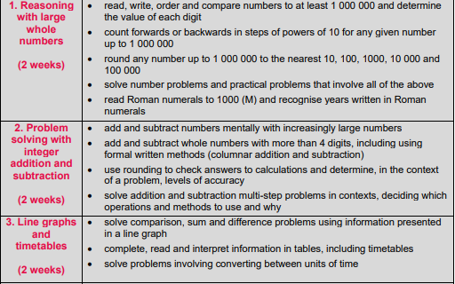  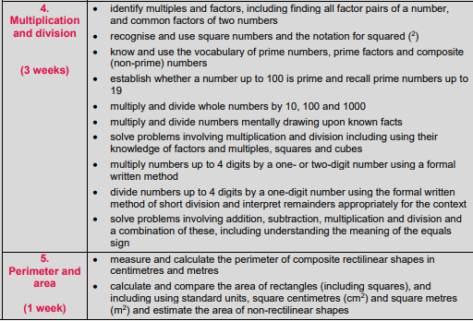 |  | 4 lessons per week.  Daily maths meetings  Times tables testing – half termly and teaching.  Times tables practise daily/weekly.
Maths sequences |  |  | Mental methods taught from Year 5 progession document – revisit year 4 before starting Year 5 – then practise through daily fluency sessions.
English sequences | GPAS | Autumn 1 SWST Baseline Y4 GPAS WR assessment  Nouns/pronouns/noun phrases  Fronted adverbials and commas recap  Plural and possessive ‘s  Inverted commas  Relative clause/subordinate clause  Modal verbs indicating degrees of possibility  Adverbs to indicate degrees of possibility | In Autumn 1 assess spellings using SWST Y4 and Y5  Baseline assessment on Y4 end of year GPAS WR and VR assessment  Weekly discrete lesson for grammar
English sequences | Reading | Accelerated reading assessment  VIPERS questions once a week.  Reading for pleasure  1:1 Reading  Whole class read for English | At beginning of Autumn 1  Once a week  Daily timetabled reading sessions  Once a week  Daily reading session  Beowulf
English sequences | Writing | To predict what the book is about from the front cover.  To write a non-chroological report on ancient Greeks.  To write a diary entry  To write a setting description of Camp Half blood.  To write a persuasive brochure.  To write the next chapter after finding out he’s Poseidon’s son.  To write a diary from a different point of view.  To write a poem about the Greek Gods | Using front cover to predict what will happen in the book.  Look at different examples of brochures, unpick key features, plan,  Using Alan Peat boxing method.  Children to use WAGOLL and WABOLL to write their version in sections.
English sequences | Vocab/Spelling | Teaching of scode spelling scheme, baseline test and follow up test. | Using the ppt and worksheets - 20 minute lesson, 4 times a week.

