Key texts
Macbeth – A Shakespeare Story – Andrew Matthews.
Tudor poetry

Tudors
Who lives in a Tudor House?
Enrichments
Visit to Tatton Park for Tudor Experience Day.

 | Word of the week Spring 1 Spring 2
Week 1 | Week 2 | Week 3 | Week 4 | Week 5 | Week 6 | Week 7
Baseline | ambivalent | recognise | curiousity | desperate | ignore | practice/practise
Baseline | sarcasm | Sacrifice | Restaurent | espeically | suggest | aloud/allowed

 | What will I know? | How will I learn it? | Vocabulary
History | Use primary and secondary sources. Record and communicate knowledge in different forms.  Study different aspects of life of different people – difference between men and women.  Relate current studies to previous studies. Compare accounts of events from different sources and offer reasons for different versions of events.  Examine causes and results of great events and the impact on people.  Compare life in early and late times studied and offer reasons for different versions of events.  Compare an aspect of Tudor life with the same aspect of MM. | Who were the Tudors ?  What is the difference between lives of rich and poor Tudor?  What evidence we have from the past tells us about the Tudors?  How does Tudor houses compare to Roman houses in our locality?  Who was Henry VIII and how did he affect the local area? How did reformation affect religion in Britain?  What was life like in Elizabethan England compared to Henry the Eighth's reign?  How did the Tudors celebrate in Speke Hall compared to today? | Catholic, Protestant, Tudor Rose, War of the Roses, reformation, Henry VIII, farthingale, scythe, corset, ruff, civilization, innovation, invention, modern world, Thornton Hough, St Hilary’s Church, Speke Hall.
Geography | Identify and describe the significance of the Prime/Greenwich Meridian and time zones including night and day (Science space topic – stand alone topic).  Know about the physical features of coasts and begin to understand erosion and deposition.  Know and describe where a variety of places are in relation to physical and human features. | What did a Tudor village look like?  What did Moreton look like in Tudor Times?  How has Moreton’s coastline changed since Tudor times?  What do the physical and human features of Moreton tell us about life in Tudor times? | County, region, country, time zone, physical and human features, erosion, deposition, coastline,
Art / DT | Theme: Tudors in our Town  - Focus: DT – Textiles (Use all stitches to combine fabric shapes)  - Medieval weaving  - Focus: drawing/ painting  - Tudor portraits  - Focus: DT – Mechanism (pulleys/gears)  - Links through science.  Focus artist/designer – Historical portraits through time.  Craft Makers: weavers | Creating Tudor style flags using a variety of different stitching types and fabric shapes.  Draw and paint Tudor portraits.  Research, plan, design, make and evaluate a product that uses pulleys or gears linked to Tudor times. Children to create own ideas within set parameters. | Cross stitch, running stitch, bastin stitch, back stitch, hemming stitch, sketch, shading, tone, texture, blend, plan, design, technology, plan, product, data, construct, produce, equipment, evaluate. fabric, colour, pattern, shape, texture, glue stick, scissors, sew, needle, felt, hessian, scraps, wool, yarn, thread, fur, tweed, silk, satin, net, weave, mixed media, collage, applique, layers, combine, opinion, tie-dye, natural, synthetic, bunching, dip, soak, resist, stitching, embroidery, cross stitch, running stitch, stem stitch, shrunken, matting, daub, emblem, motif, ornamentation, geometric, stylised, abstract, fray, taffeta, organza, embellished, manipulated, warp, weft, replicate, soft sculpture  secondary (colour), light, dark, thick, thin, tone, warm, cold, shade e.g. different shades of red, green, blue, yellow, bright, pointillism, colour wash, background, abstract, natural, bold, delicate, detailed, colour descriptors, (e.g. scarlet, crimson, emerald, turquoise), watery, intense, strong, translucent, tint, foreground, middle-ground, scenery, rural, urban, townscape, seascape, landscape, representational, imaginary, impressionist, idealised, swirling, stippled, transparent, opaque, horizon, traditional, modern, splattered, dabbed, scraped, dotted, stroked, textured, flat, layered
Computing | Know when the input is changed, the output is also changed.  Know what ‘and’ ‘or’ and ‘not’ code blocks are.  Know what events are.  Know that devices must agree on security, speed and style of connection before they can transmit data. Know that this is called a handshake signal. | 1 weekly lesson using IPADs focusing on Video Editing (splicing and Imotion)  Creating a non-linear presentation – creating an interactive timeline.  At the end of each topic, children create a Google Forms quiz for their friends to complete. Data from this could be used in other projects.  Create a fact file on Henry VIII. First, plan the layout of the page, then write content and place within page. Use spell check tool and have a friend evaluate. | Debugging, programming language, command, algorithms, programme, input and output,code blocks, devices, handshake signal, Video editing, splicing, Imotion, non-linear presentation, buttons, slides, google slides, data, layout, content, evaluate
Music | Instruments: to consolidate and continue with recorder (including alto and tenor), glocks and other instrument. In addition, to use synthetic instruments to improvise and to compose.  Improvisation and composition; to be able to improvise and to compose using notes from the keys C, Am, F, G, D  Listen and Appraise; answer questions relating to musical elements, focusing on structure and texture, with musical evidence. | Use recorders or glocks to compose Tudor style pieces.  Use IPADS to create sounds they can then use to compose and create own pieces. | Pulse, rhythm, pitch, dynamics, notation, tempo, timbre, structure, style, texture, Style, crotchet, quaver, semi-brieve, minim, treble clef, base clef.
Science | Light (Earth and Space):  Describe the movement of the Earth and other planets relative to the sun in the solar system  Describe the movement of the moon relative to the Earth.  Describe the sun, Earth and moon as approximately spherical bodies.  Use the idea of the Earth’s rotation to explain day and night and the apparent movement of the sun across the sky  Foces and Electricity:  Explain that unsupported objects fall towards the Earth because of the force of gravity acting between the Earth and the falling object  Identify the effects of air resistance, water resistance and friction, that act between moving surfaces  Recognise that some mechanisms including levers, pulleys and gears allow a smaller force to have a greater effect | Weekly 1hr 30 lessons for Science  Vocabulary check list  Assessment at end of unit  Using science snapshots to recap/explain what the children have learned weekly at the beginning of a science lesson.  Introduction to the universe: Vocabulary checklist and unit cover. Look at developing an understanding of the universe.  The solar system: W.S – Name and order the planets in the universe and use a mnemonic to help remember. Research a planet of choice and describe it.  The moon and other celestial bodies: W.S –Recap the planets mnemonic. Explain different objects in the universe. Describe the different phases of the moon.  A day on earth: W.S –Discuss key vocabulary (spherical, axis, day, year, orbit. Create and model the movement of the Earth with objects. Children to write their findings.  The seasons: W.S – Develop children’s understanding of the seasons and why the sun appears a different heights throughout the year.  The Universe and astronomers: W.S –Research and describe the thoughts and ideas of scientists of the past and what we know today  Recap Forces from previous year – describe what push and pull is, giving examples. Investigate outside or in the classroom for things you can push and pull  Forces: W.S –  Develop understanding of force and describe what happened when you apply force to something. Using a bike, trike demonstrate how you can speed up or slow down and change direction. Describe what happened in a paragraph.  Friction: W.S –  Develop an understanding of friction, describe some of the effects of friction and investigate how friction can change on different surfaces.  Air resistance W.S –  Further develop an understanding about forces and air resistance, describe gravity as a force and collect results and conclude findings around an air-resistance investigation(parachutes)  Theory of Gravity W.S –  Develop an understandinf of gravity and describe the force. Research and describe how scientists helped develop the theory of gravity.  Levers: W.S –  Develop an understanding of levers and recognise and describe how levers can be used to allow a small force t have a greater effect.investiagte how levers behave by creating a lever.  Pulleys: W.S –  Develop an understanding of pulleys as a simple machines. Investigatewhat a pulley is and its advantage by making a simple pulley. | Phases of the moon, waxing, waning, crescent, first, new, eclipse, earth, planets, movement, solar system, universe,mnemonic, seasons, forces, push, pull, gravity, air resistance, water resistance, friction,levers, pulleys, mechanisms.

 | What will I know? |  | How will I learn it?
Maths sequences | 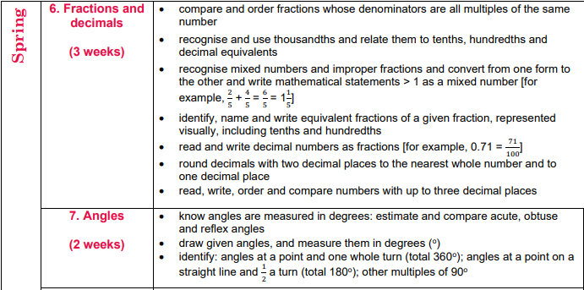  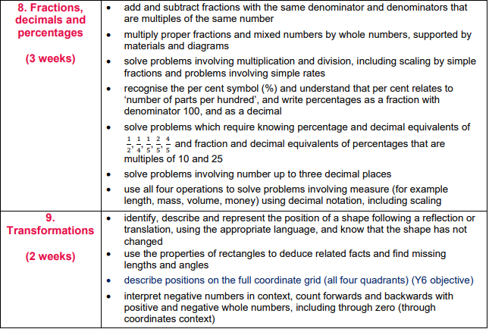 |  | MNP lessons – 5 lessons per week. Chapters 6-9  Daily fluency practise – mornings.  Mental maths/Year 6 ready lesson – once a week.  Times tables testing – half termly and teaching.  Times tables practise daily/weekly.
Maths sequences |  |  | Mental methods taught from Year 5 progession document – then practise through daily fluency sessions.
English sequences | GPAS | Parenthesis  Commas, Brackets and dashes,  Expanded noun phrases  Tenses – Perfect form of verb to mark relationships of time and cause. | Weekly discrete lesson for grammar
English sequences | Reading | VIPER questions once a week.  Reading for pleasure  1:1 Reading  Whole class read for English  ½ termly reading assessment on accelerated reader. | Once a week  Daily timetabled reading sessions  Once a week  Daily reading session
English sequences | Writing | I can write a prediction based on the front cover.  I can rewrite a scene from Mabeth into modern English.  I can write a persuasive speech (Should Macbeth be King)  I can write a character description  I can write a persuasive letter  I can write a playscript  I can write a non-chronological report on Henry the eighth.  Poetry: Shakepeare Sonnets and rhyming poem based on the Song of the Witches (Macbeth) | Write a prediction on what the book is about. Children to read and act out a scene from Macbeth and write a modern version. Children to write a for and against speech on whether Macbeth should be king. Write a character description of Lady Macbeth. Write a recount Write an information piece on Henry the Eighth. Read and write a sonnet using iambic pentameter. Write a poem based on the Song of the Witches
English sequences | Vocab/Spelling | Teaching of scode spelling scheme, baseline test and follow up test. | Using the ppt and worksheets - 20 minute lesson, 4 times a week.

