CHRIST CHURCH MORETON C.E. PRIMARY SCHOOL

EYFS POLICY

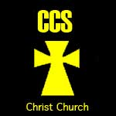

Together we can do all things through Christ who strengthens us

Reviewed policy agreed by Governing Body on: December 2022
Reviewed policy shared with staff on: December 2022
Policy to be reviewed again on: December 2023

“The goal of early childhood education should be to activate the child’s own natural desire to learn.” – Maria Montessori

Contents
Section 1
Introduction to the EYFS at Christ Church CE Primary School
Section 2
Staffing Information
Section 3
Curriculum
3a) Provision and Learning Environment
3b) Structure of teaching and Learning
3c) Areas of Learning
3d) Characteristics of Effective Learning
3e) Outdoor learning
3f) Curriculum Enhancements
3g) Learning Journeys and Evidence keeping
Section 4
Management and Organisation
Section 5
Assessment
5a) Formative and Summative Assessment
5b) Quality Assurance and Moderation
5c) Marking and Feedback
Section 6
Positive Relationships
Section 7
Transition
7a) Transition into Pre School
7b) Transition from Pre School / F1 into F2
7c) Transition to Year 1
Section 8
Behaviour
Section 9
SEND
Section 10
Inclusion
Section 11
SRE
Section 12
Safeguarding
Section 13
Health and Safety
Section 14
Intimate Care
Section 15
Monitoring and Review of the EYFS

Section 1
Introduction to the EYFS at Christ Church CE Primary School
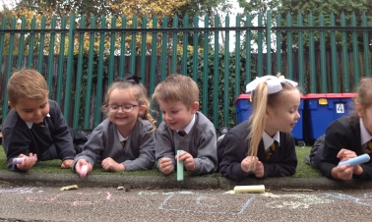

“Every child deserves the best possible start in life and support to achieve their full potential. A child’s experience in the early years has a major impact on their future life chances. A secure safe and happy childhood is important in its own right, and it provides the foundation for children to make the most of their abilities and talents as they grow up. When parents choose to use early years services they want to know the provision will keep their children safe and help them to thrive. The Early Years Foundation Stage is the framework that provides that assurance.”
(Early Years Foundation Stage Profile - Department for Children, Schools and Families 2012)

The Early Years Foundation Stage (EYFS) applies to children from birth to the end of Foundation Stage 2 (FS2). At Christ Church CE Primary School, all children join us in FS2, at the beginning of the academic year in which they are five. We also have a Pre School provision available to younger children, parents can choose to apply for a place in our Provision for the term after they turn 3 years old.

At Christ Church CE Primary School we pride ourselves on creating a loving, nurturing environment in which children feel safe and secure. Our EYFS is rooted in strong Christian values and provides children with the opportunities to explore and develop their own faith and beliefs. Teaching and learning is underpinned by values that support the social, emotional, moral and spiritual growth of our children and regular opportunities to reflect are encouraged through shared collective worship and building positive relationships with Christ Church and the wider community. Children are encouraged to be inspired by the moments of ‘awe and wonder’ and to reflect and respond to these in personal ways. The staff in EYFS show great care for all children and families, ensuring that all children are able to enjoy and achieve. We are committed to creating and maintaining a strong home – school partnership to best support the needs of all individuals. Children feel happy in the EYFS at Christ Church and continue to flourish as individuals as a result of the effective learning environment that we have established. The children at Christ Church leave the EYFS with motivation and enjoyment of learning, providing them with the strong, secure basis for all their future learning and development in school and beyond.

Section 2
Staffing Information

The EYFS at Christ Church recognizes that the adults that work with the children contribute to their overall learning and development and therefore staffing is structured as follows:

- One EYFS Lead that is part of the wider Leadership Team
- Two FS2 Class Teachers and our school SENDCO based in F2 one day every week
- A team of four Level 3 and one Level 2 Teaching Assistants that work across EYFS
- A SEND Support Teaching Assistant

The staff within the EYFS are provided with regular opportunities to develop their professional skills and knowledge of child development within the Foundation Stage. Phase meetings are held half termly to ensure all staff are up to date with current legal requirements and to discuss progress within the EYFS setting.

All staff within the EYFS contribute to planning, evaluation and assessment for all children. Teaching Assistants are valued for the contribution they can make to a child’s learning journey throughout their time at Christ Church.

Section 3
Curriculum

In Christ Church CE Primary School we believe that all our children matter. We give our children every opportunity to achieve their best. We do this by taking account of our children’s range of life experiences when planning for their learning.

At Christ Church CE Primary School we recognise and respect that every child is a competent learner who can be resilient, capable, confident and self assured. We recognise that children develop in individual ways, at varying rates. Children’s attitudes and dispositions to learning are influenced by feedback from others; we use praise and encouragement, as well as celebration/ sharing assemblies and rewards, to encourage children to develop a positive attitude to learning.

We meet the needs of all our children through:
- Planning opportunities that build upon and extend children’s knowledge, experience and interests, and develop their self-esteem and confidence.
- Using a wide range of teaching strategies based on children’s learning needs.
- Providing a wide range of opportunities to motivate and support children and to help them to learn effectively.
- Providing a safe and supportive learning environment in which the contribution of all children is valued.
- Using resources which reflect diversity and are free from discrimination and stereotyping.
- Planning challenging activities for children whose ability and understanding are in advance of their language and communication skills.
- Monitoring children’s progress and taking action to provide support as necessary.

Learning Through Play

At Christ Church we recognise that children should access a balance of direct teaching and child initiated learning (for further information on this balance, refer to Section 4a). Planned, purposeful play opportunities contribute to children’s experiences at Christ Church, enabling them to explore and develop their own ideas, thinking and learning.

Through play our children explore and develop learning experiences, which help them make sense of the world. They practice and build up ideas, and learn how to control themselves and understand the need for rules. They have the opportunity to think creatively alongside other children as well as on their own. They communicate with others as they investigate and solve problems. They express fears or re-live anxious experiences in controlled and safe situations.

“Children’s play reflects their wide ranging and varied interests and preoccupations. In their play children learn at their highest level. Play with peers is important for children’s development.”
(Early Years Foundation Stage, Department for Children, Schools and Families, 2007)

Section 3
Curriculum

3a) Provision and Learning Environment
At Christ Church the EYFS learning environment is set up with areas of provision that link to all seven areas of the curriculum. Each area is enhanced with open ended resources to encourage children to be responsible for their own activities and learning. Additional enhancements linked to themes or topics of interest are added to the areas of provision to encourage active learning. The provision is progressive from Pre School to FS2 and enables children to access learning at an appropriate age and stage of development. It is recognised that the learning environment should be reviewed, adapted and changed based on ongoing analysis of use, effectiveness and children’s enjoyment and enthusiasm. Staff will review this formally each half term and adapt provision as necessary.

3b) Structure of teaching and Learning
The structure of each day in EYFS at Christ Church is planned progressively from the beginning to the end of the year. It is based on cohort needs and contains a balance of adult led / taught sessions and continuous provision sessions allowing children to initiate their own learning activities. In Pre School, the day consists of large portions of time dedicated to Continuous Provision and adults teaching through planned, purposeful play as well as regular short teaching sessions underpinned by the Prime Areas. The teaching sessions allow time to be spent with Key Workers; develop language/literacy knowledge and skills based around high quality texts and nursery rhymes as well as early Reading/Phonics and Mathematics. In FS2, each day comprises of five teaching sessions with a focus on Discrete Phonics, Maths, Literacy, stories and communication activities. The time allocated for these sessions and the learning objectives / focus increases as the year progresses. Children then access Continuous Provision play and exploration opportunities in the time between these sessions to use, apply and develop their knowledge and skills.

Please see additional EYFS Evidence File for further information and examples of this progression throughout the year.

3c) Areas of Learning
We value all areas of learning and development equally and understand that they are inter connected.

The EYFS is made up of seven areas of learning:
- Personal, Social and Emotional Development (PSED)
- Communication and Language (CL)
- Physical Development (PD)
- Literacy (L)
- Mathematics (M)
- Understanding the World (UTW)
- Expressive Arts and Design (EAD)

These seven areas of learning can be divided up into the ‘Prime Areas’ (PSED, CL and PD) and the ‘Specific Areas’ (L, M, UTW, EAD). At Christ Church we provide learning opportunities and an environment that enables children to develop the basic skills set out in the Prime Areas and apply these skills within the context of the Specific Areas. In Pre School we recognise that learning in the Prime Areas provides the foundation for future learning and this should be a key focus for teaching and learning throughout the children’s time in FS1. As children progress into FS2 we value that all seven areas of learning are of equal importance in the overview of a child’s learning and development and at Christ Church CE Primary School we endeavor to provide children with a learning environment that enables them to enjoy and achieve in all seven.

3d) Characteristics of Effective Learning
The Characteristics of Effective Learning are set out as follows in the EYFS Curriculum.

Playing and Exploring
Active Learning
Creating and Thinking Critically

At Christ Church we recognise the importance of understanding child development and how children choose to play and learn. The Characteristics of Effective Learning are considered when planning and delivering the EYFS curriculum to underpin all learning and development of the seven areas of the EYFS curriculum.

At the end of the academic year, staff will provide a written commentary linked to each individual child taking into consideration the Characteristics of Effective Learning, this will support their transition into the next year group. This commentary will also form part of the child’s end of year written report to inform parents.

Section 3
Curriculum

3e) Outdoor learning
The use of an outdoor learning environment as well as an indoor environment is as important in providing children with varied learning opportunities and experiences at Christ Church. The setup of the outdoor environment at Christ Church is such to allow for exploration, investigation, cooperation, teambuilding, physical development and communication skills. It draws on using nature to enhance provision and encourage children to notice the world around them whilst fostering a care and responsibility for our environment and wider world. Staff at Christ Church recognise that the indoor and outdoor environment should be different and that opportunities outdoors should encourage children to learn how to manage risks in a safe and structured environment. The outdoor learning environment consists of areas that are available for all children across EYFS to access, areas specifically for Pre School and those specifically for FS2. This enables staff to plan and deliver provision that is targeted at children’s interests and next steps in learning effectively. Children at Christ Church are able to move freely between indoor and outdoor provision during Continuous Provision to access the wide variety of planned learning opportunities.

3f) Curriculum Enhancements
Alongside the curriculum learning that takes place within school, additional enhancements are planned and delivered to ensure that children are excited and motivated to engage in learning opportunities.

A dinosaur crashed into a classroom and left muddy footprints! The children enjoyed investigating where they came from, which type of dinosaur it might have been, writing letters and posters to inform the other children in school of the event, estimating, measuring and comparing the size of the footprint to our feet!

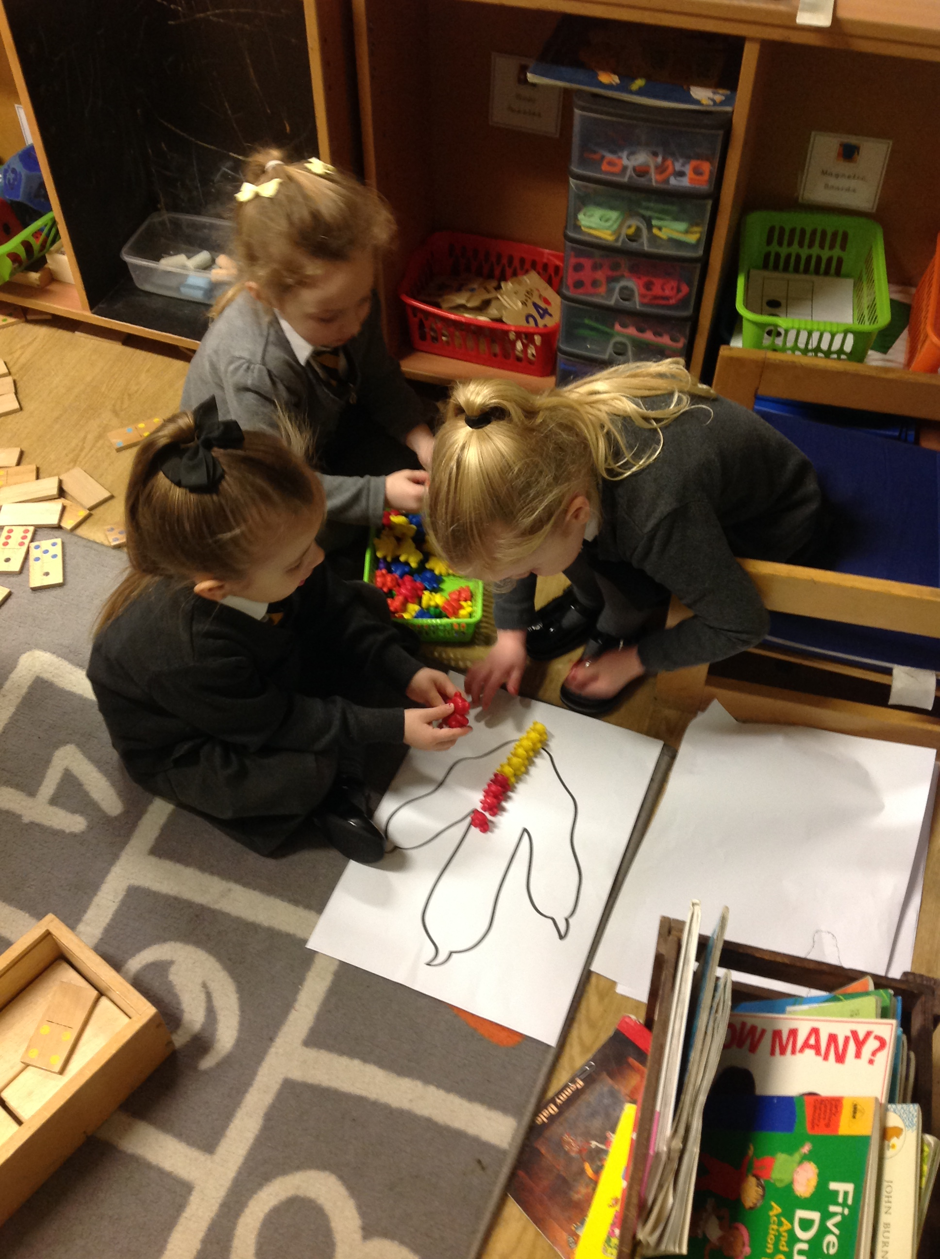
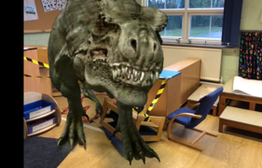
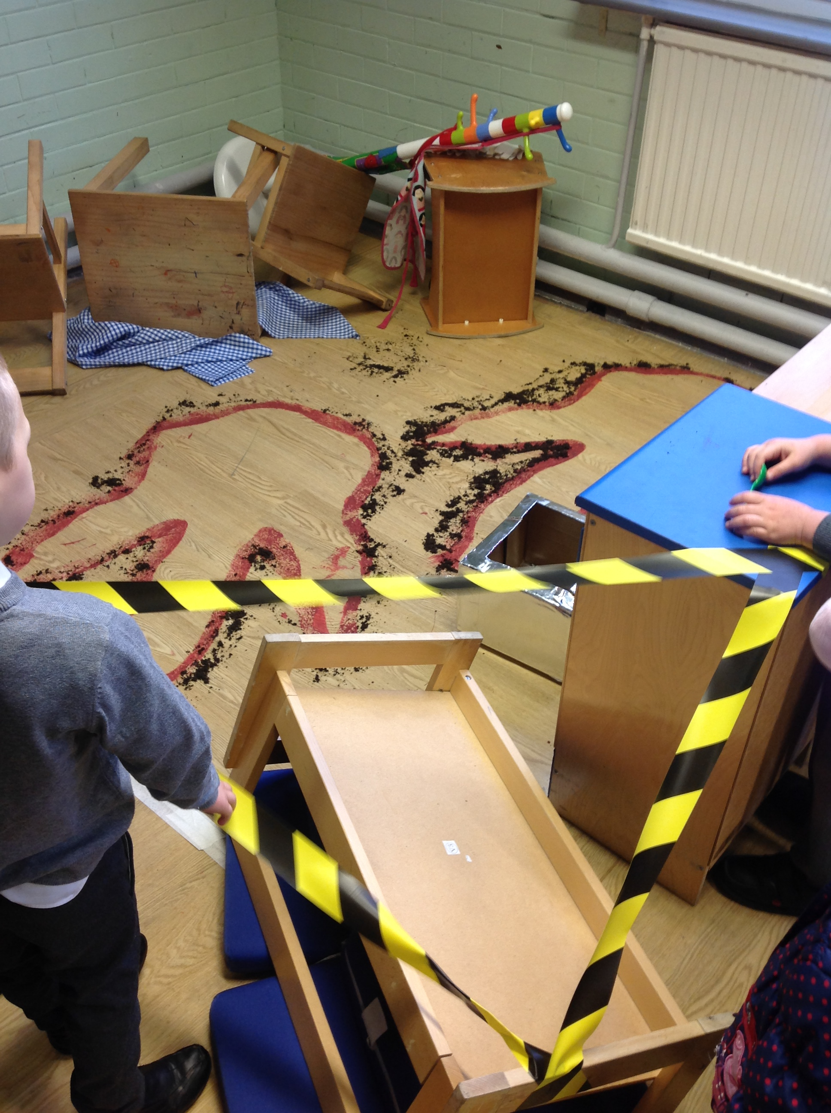

A local farmer need the help of FS2 to hatch some eggs that didn’t have a mummy! The children learnt about how to take care of the eggs, watched videos to understand the chick development and took responsibility of caring for the eggs and chicks once they arrived!

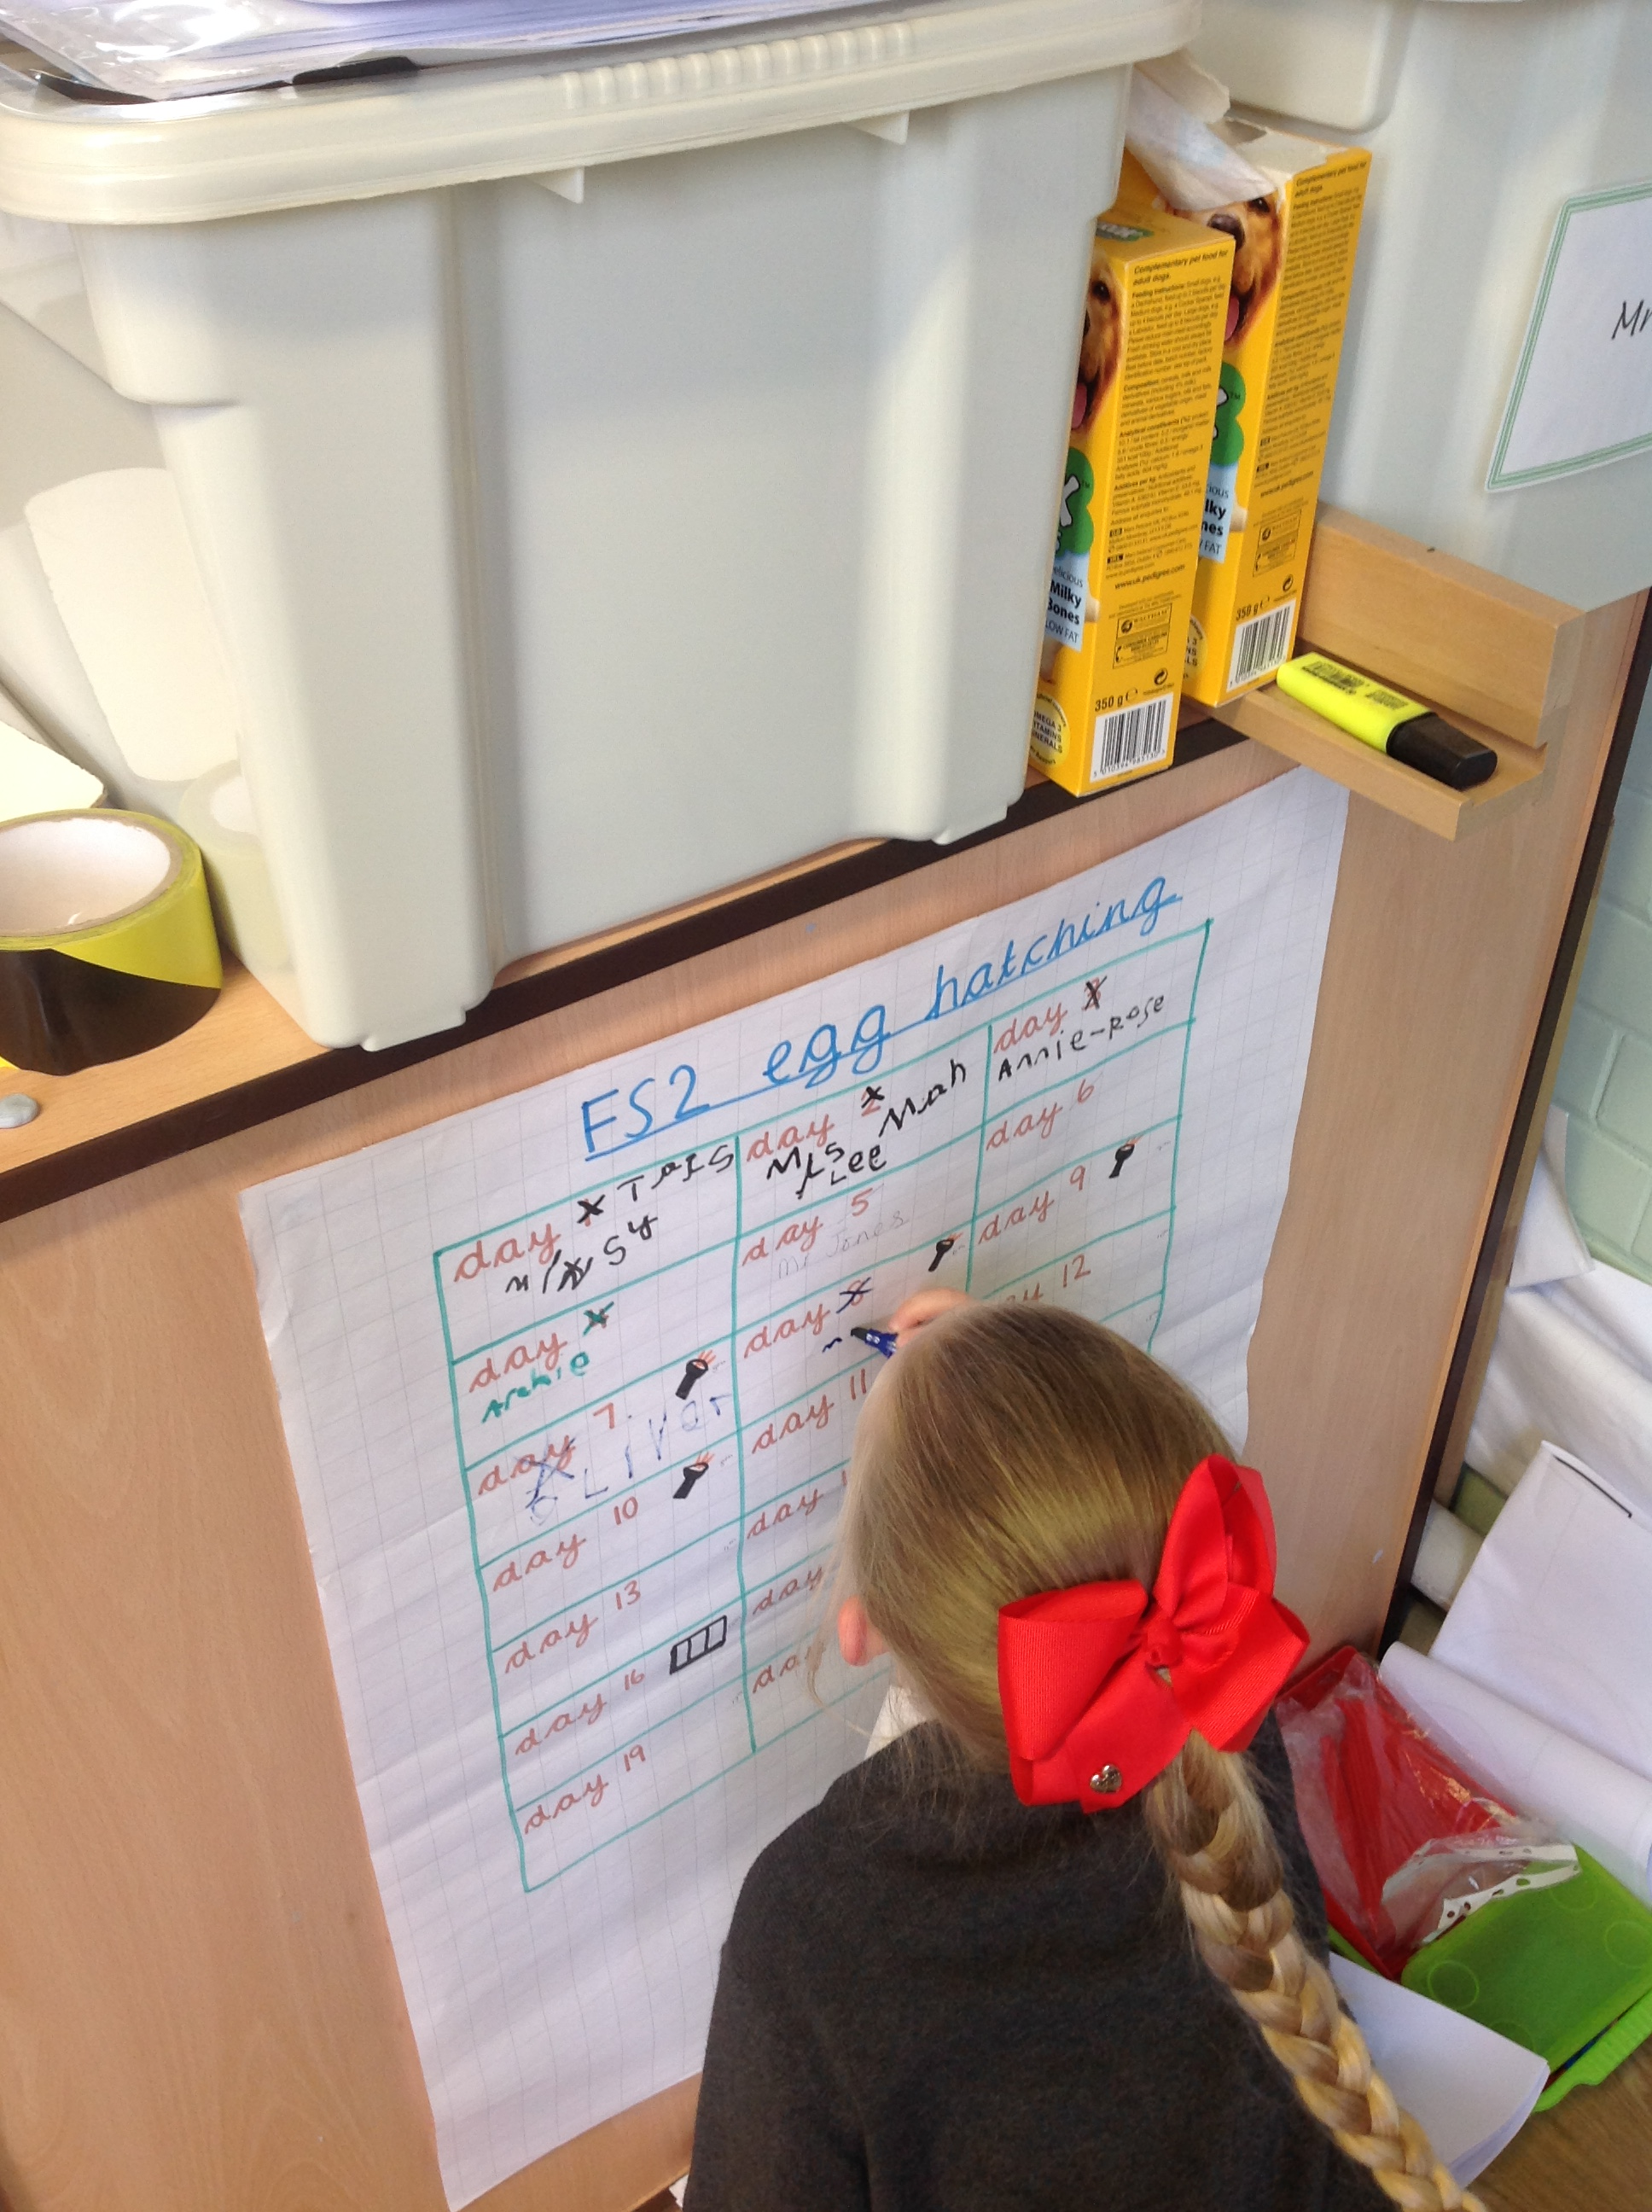
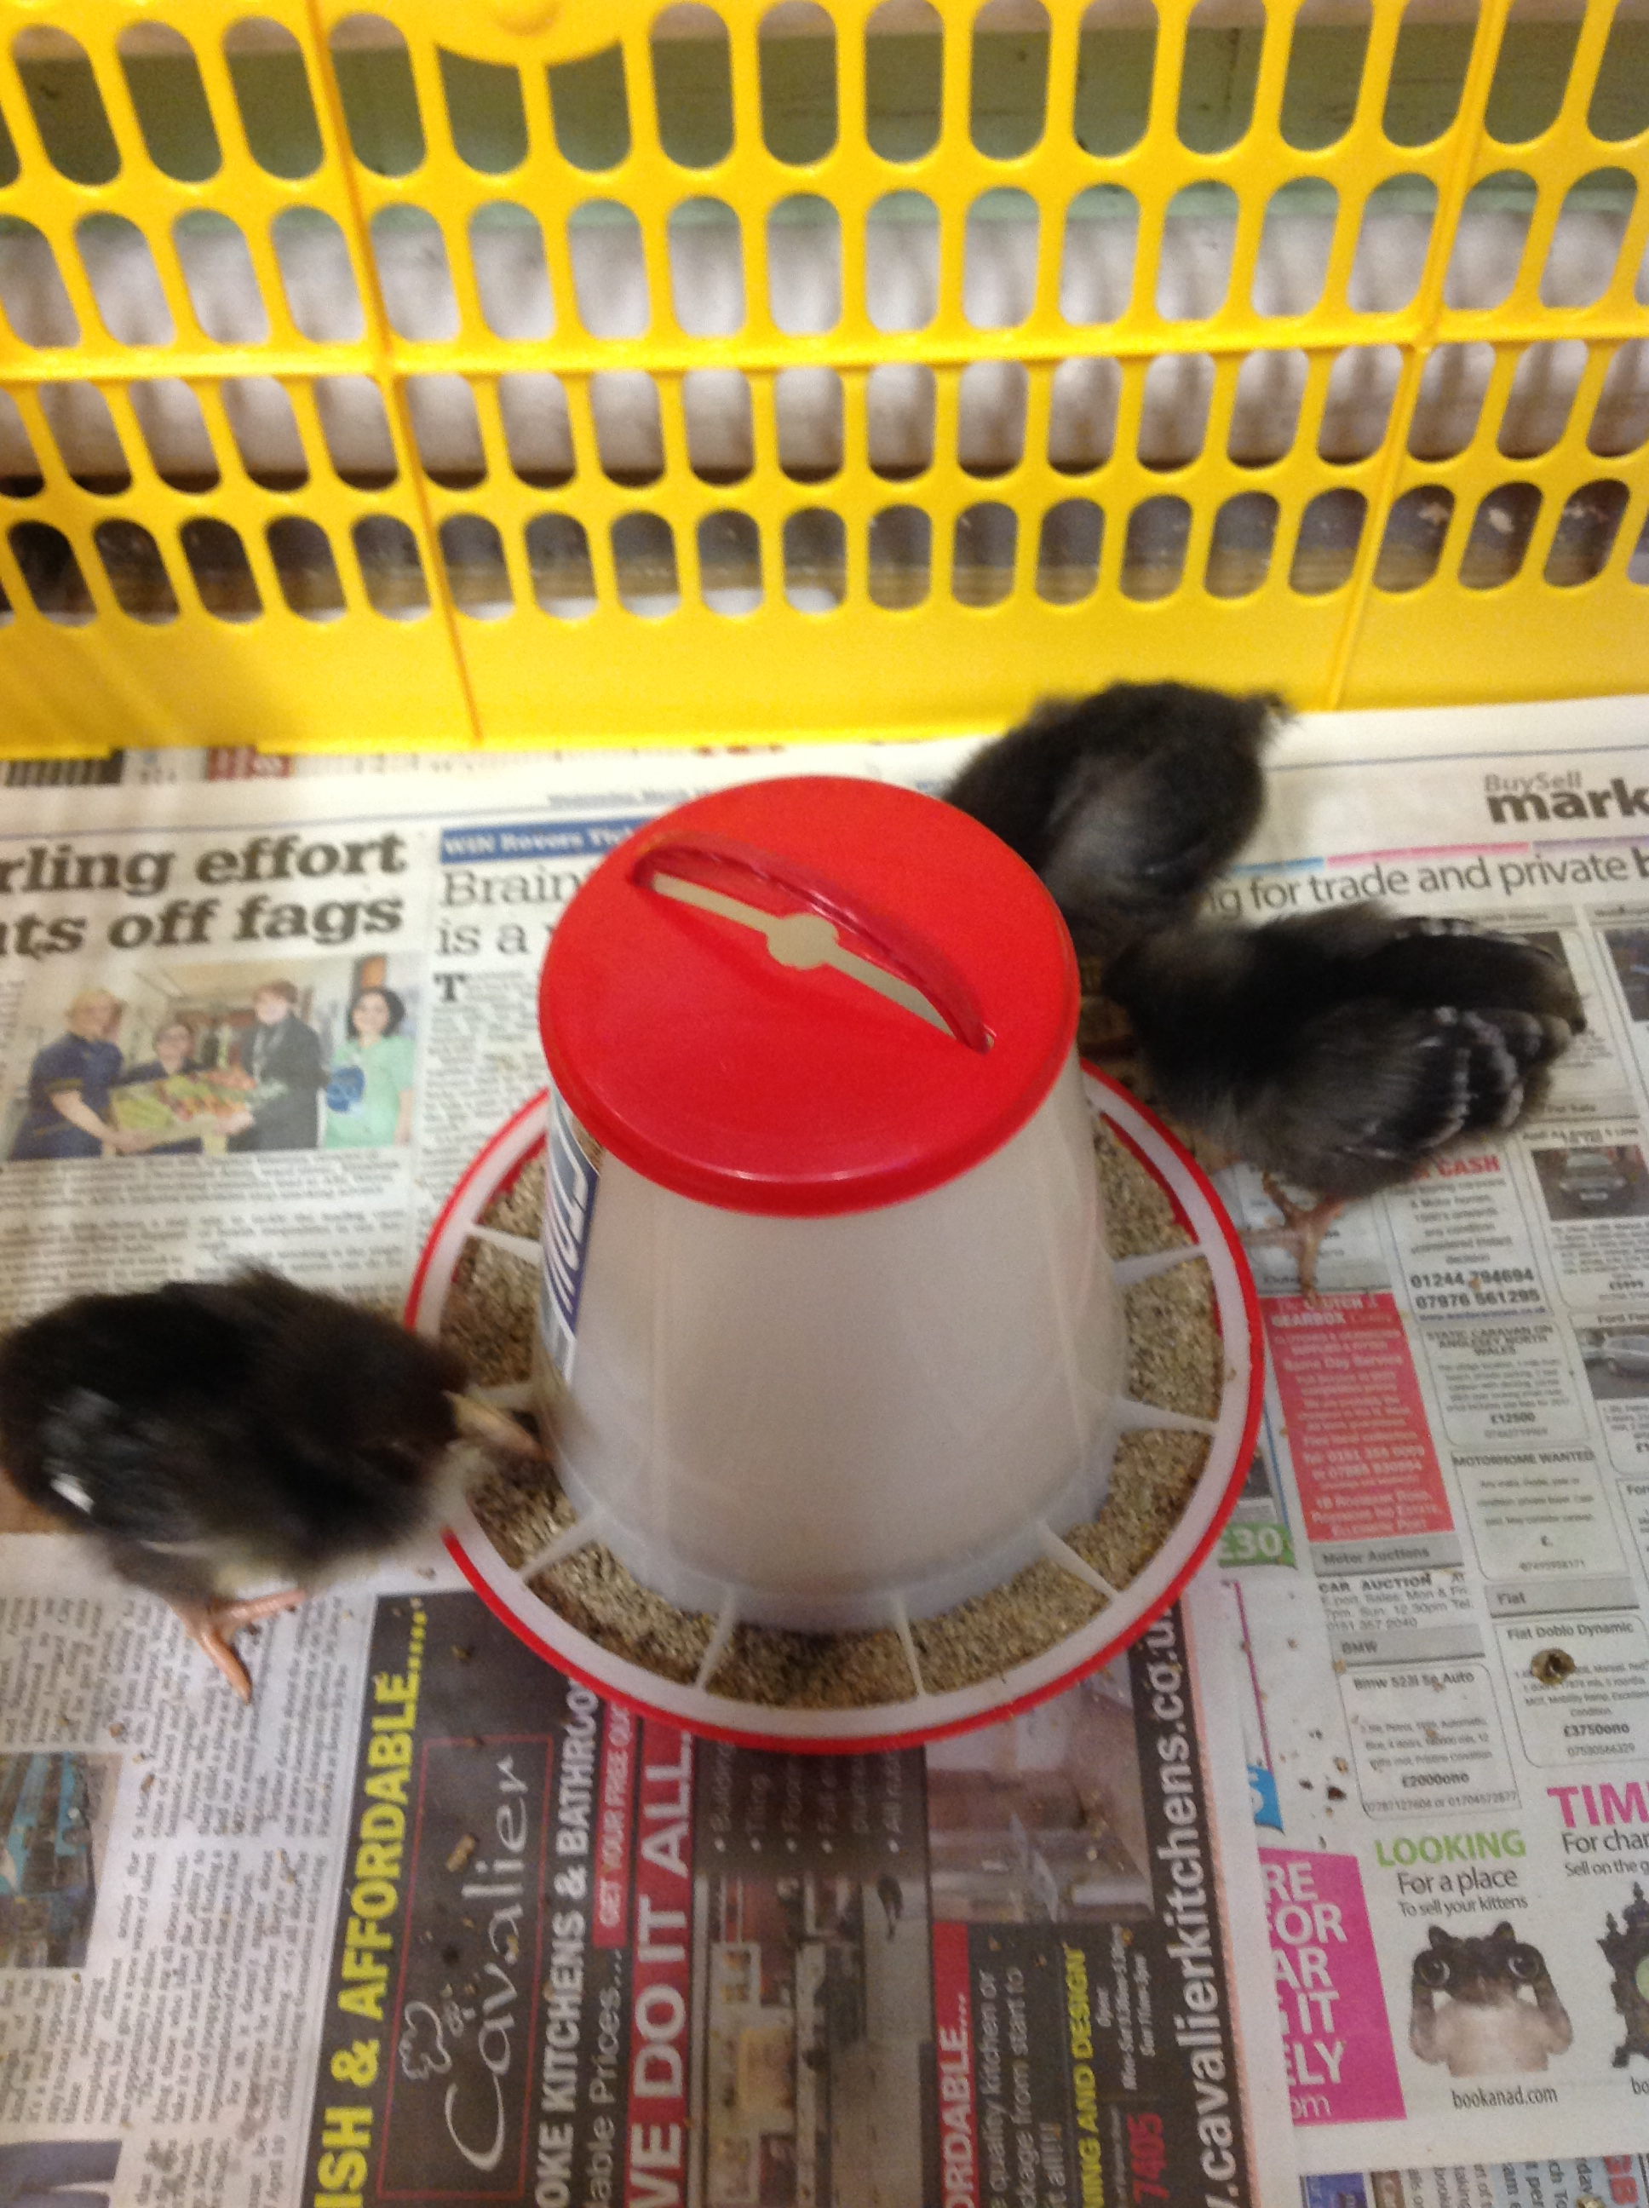
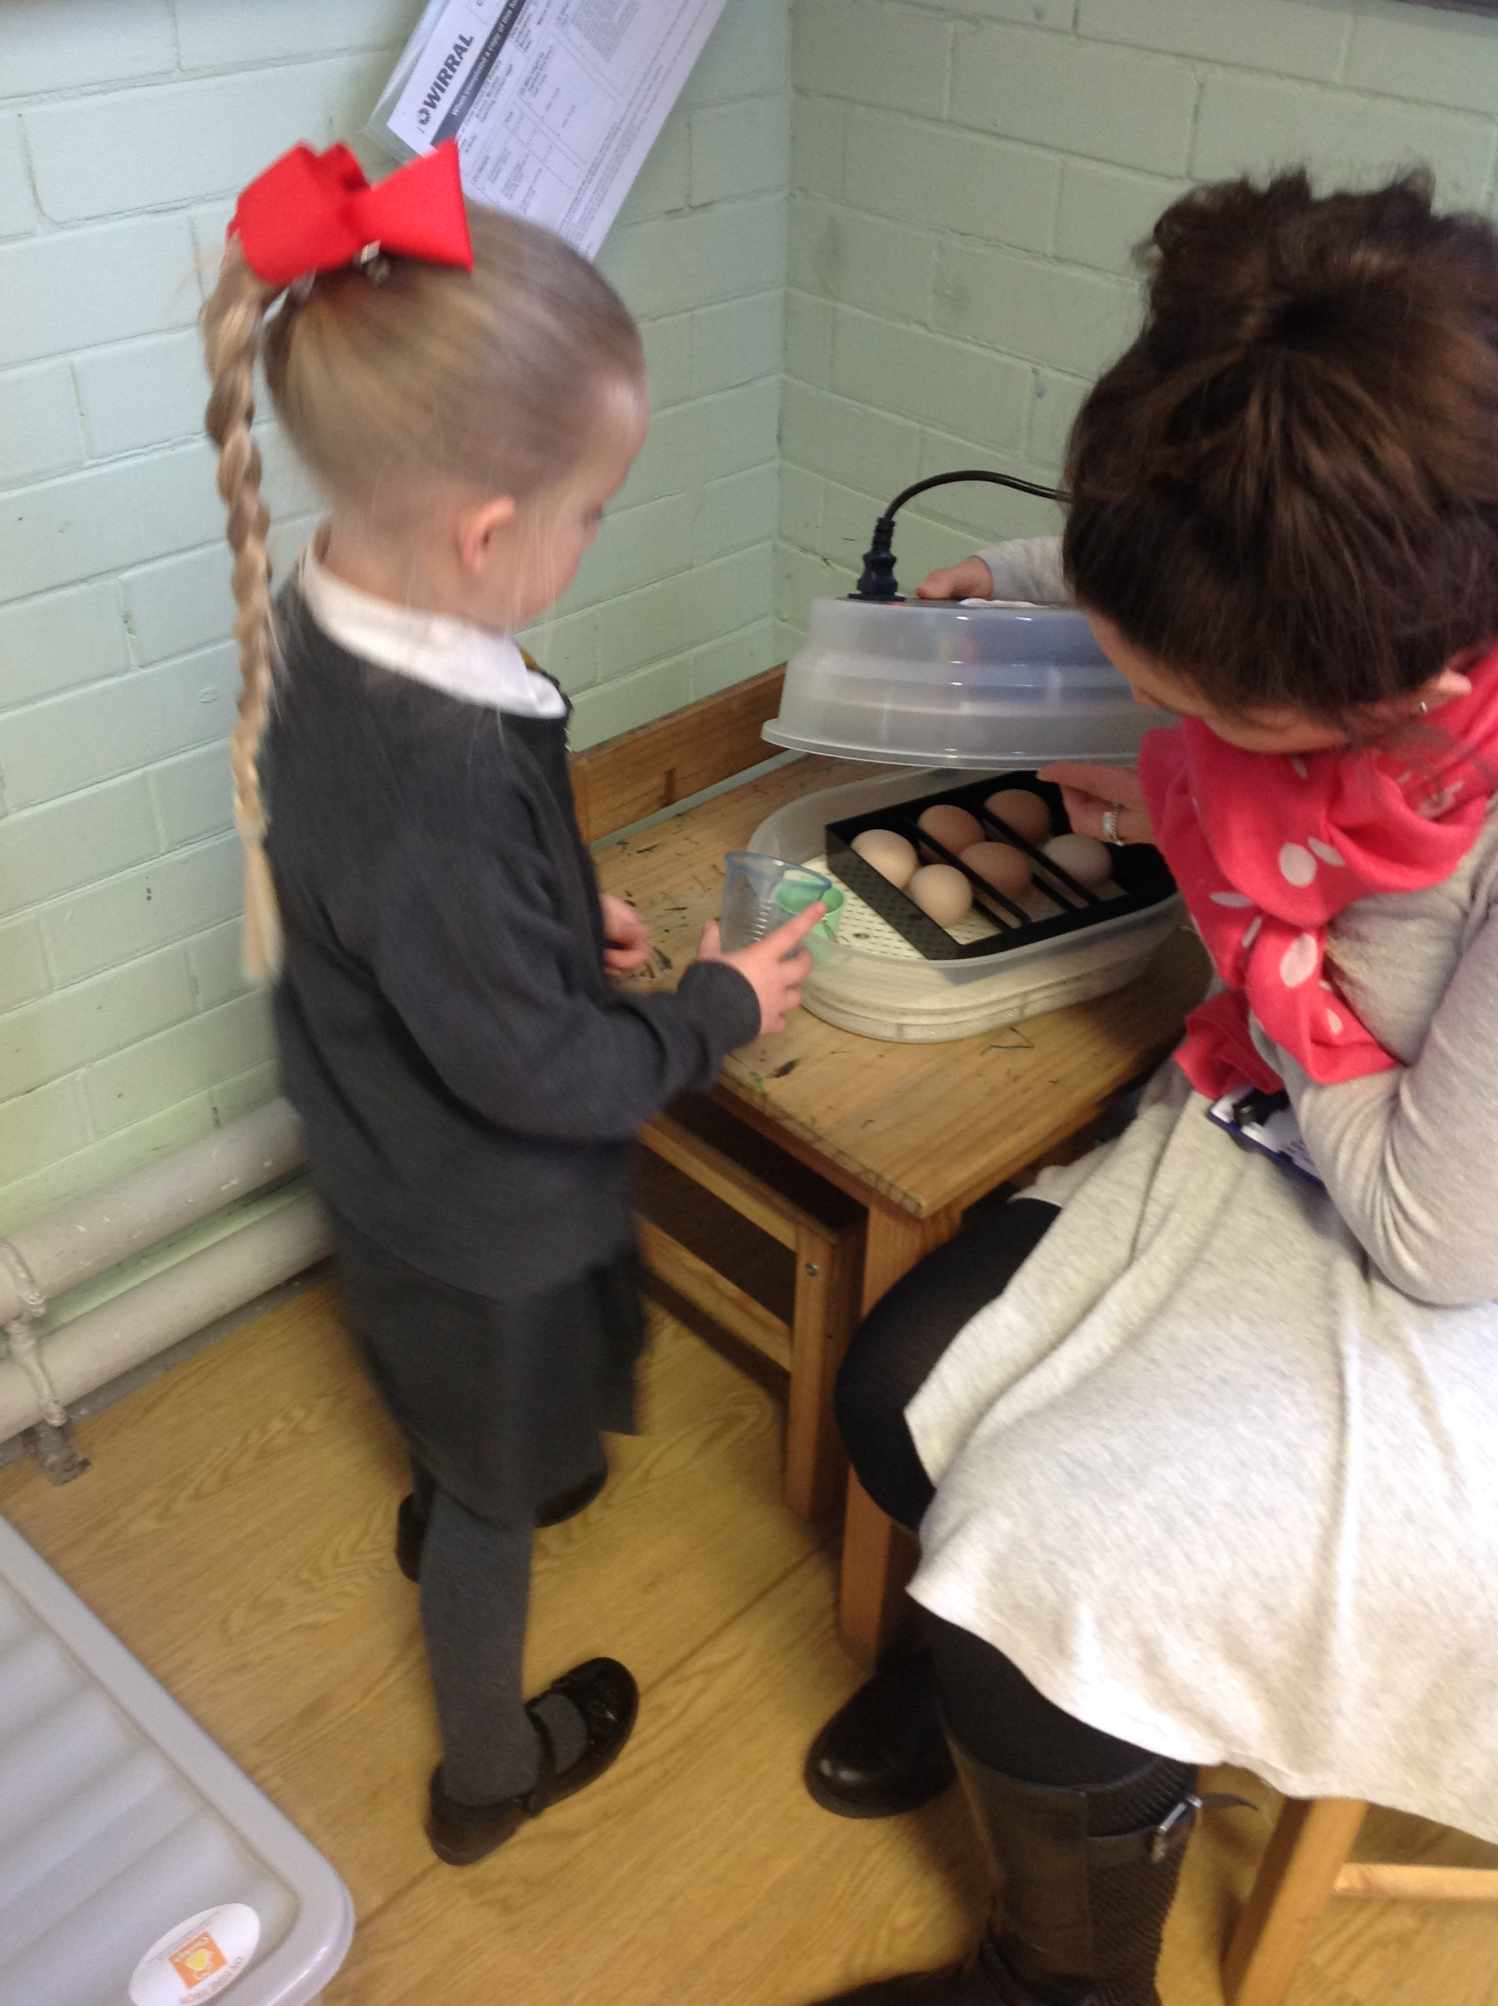
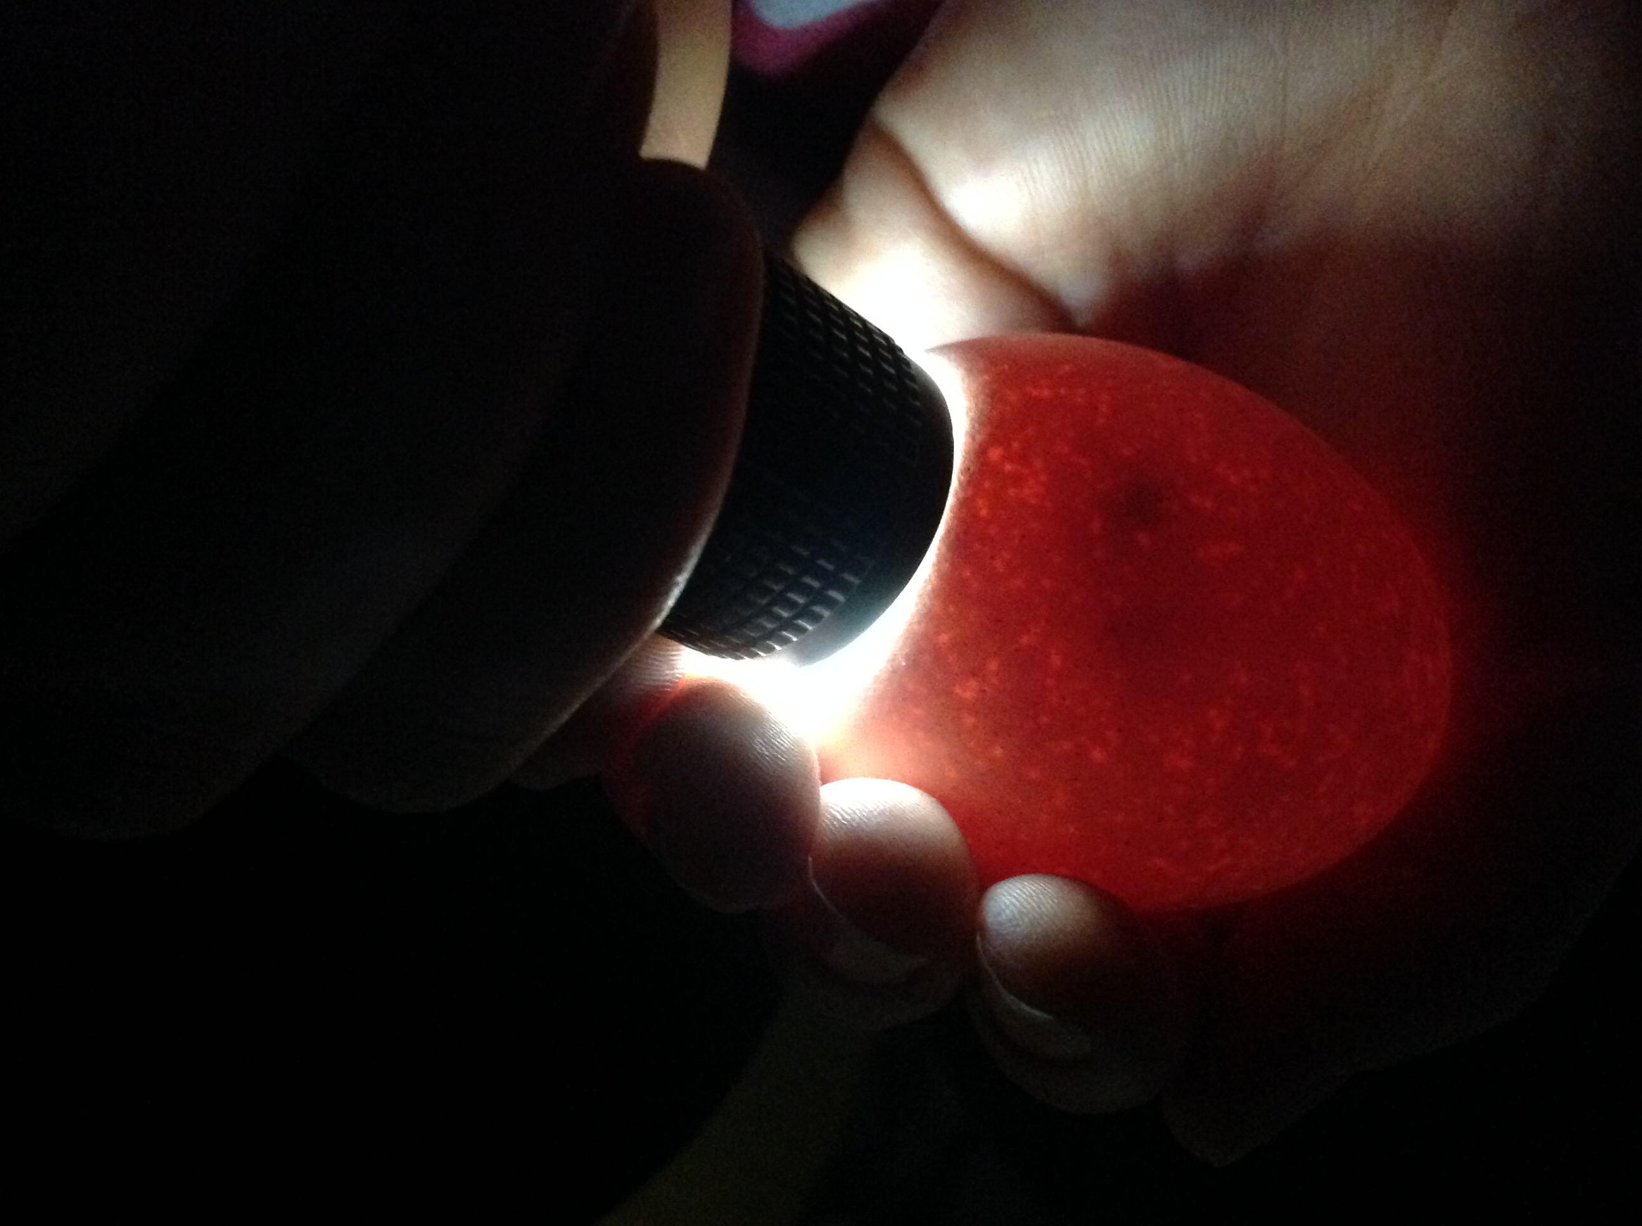

Visitors are invited to school, trips within the local area and other educational visits are organized to provide children with further exciting learning opportunities to build on their interests.
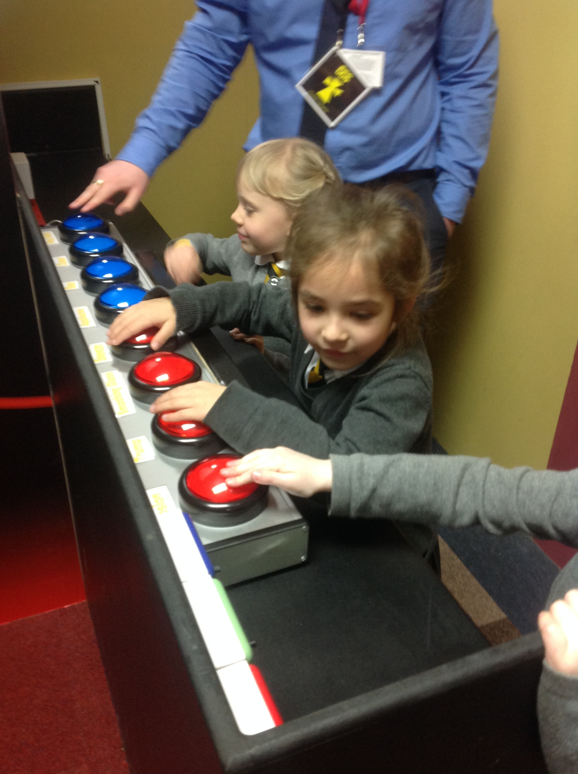
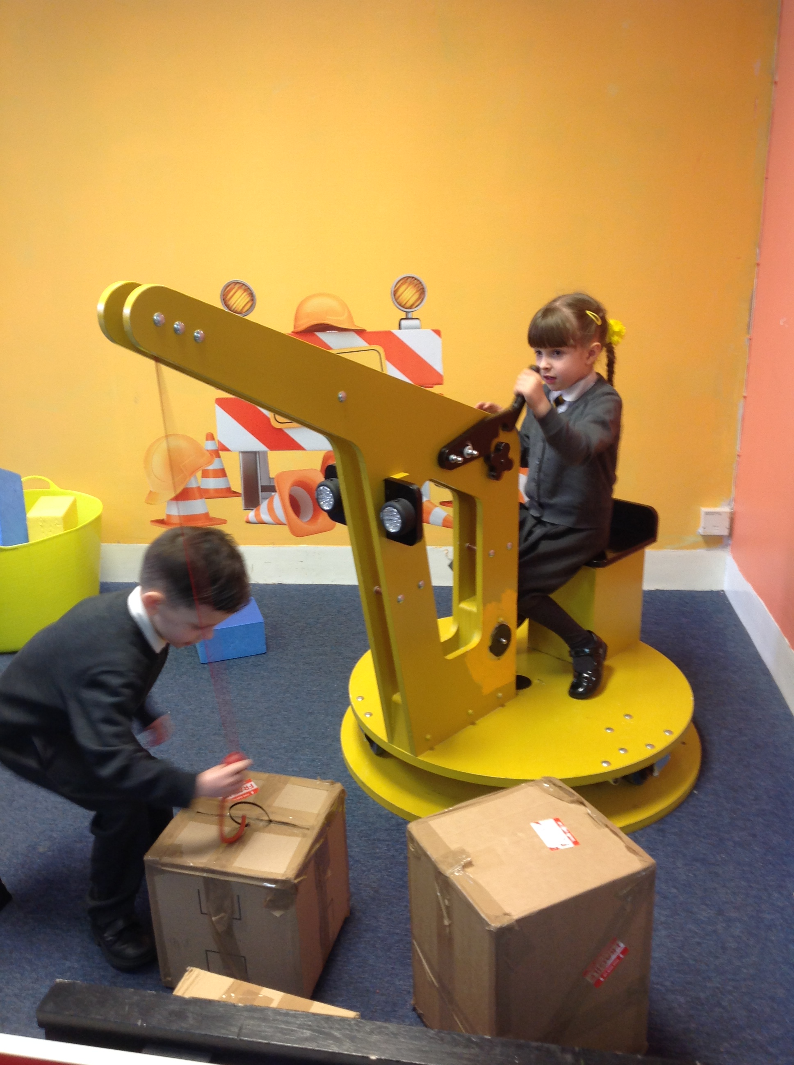
The EYFS children were particularly interested in exploring and investigating how things work. We went on a trip to Imagine That! And learnt to be scientists, artists, inventors and much more!
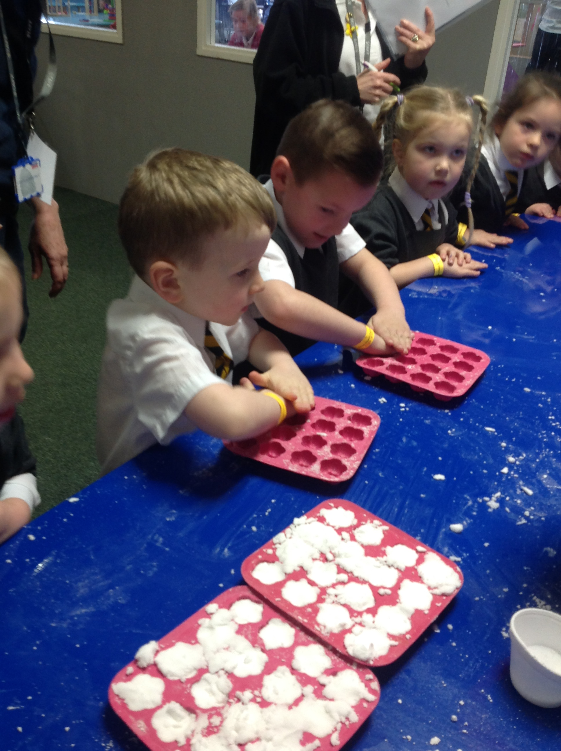
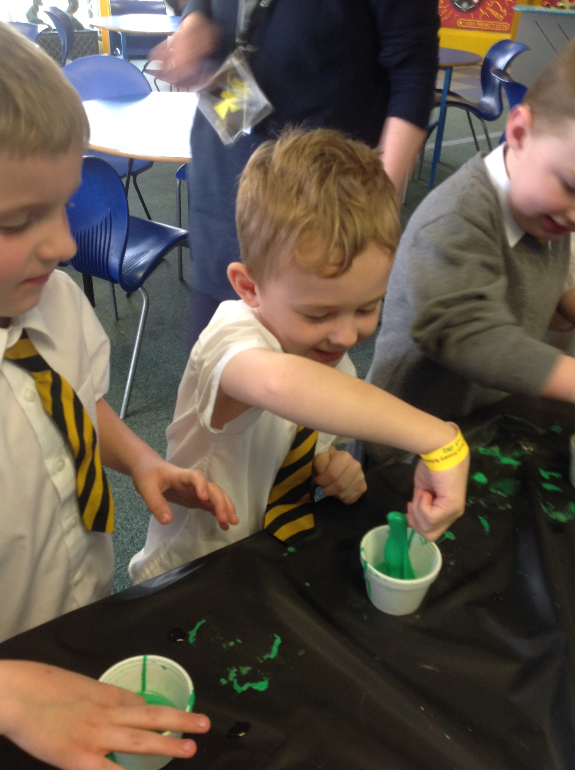

3g) Learning Journeys and Evidence keeping
At Christ Church we understand the importance of recording children’s learning and progress. In FS2 Each child will be given a Learning Journey folder, in which any work or activity that demonstrates progress in learning will be annotated and kept as evidence. In addition to this, observations of learning in action will be taken using Tapestry, an online photographic record of children’s learning and progress for each child. In Pre School, learning will be recorded as part of a whole class Learning Journey book which children will have the opportunity to revisit and share as part of their provision. Staff and parents will use Tapestry to record ‘special moments’ that capture key points of children’s learning and development. Monitoring and moderation of this evidence is discussed in Section 5. We recognise the importance of parents and carers contributing to each child’s learning journey and opportunities for this are planned regularly (for further information see Positive Relationships).

Section 4
Management and Organisation

The organisation of staffing in EYFS at Christ Church is as follows:

Staffing
- One EYFS Lead that is part of the wider Leadership Team
- Two FS2 Class Teachers and our school SENDCO based in F2 one day every week
- A team of four Level 3 and one Level 2 Teaching Assistants that work across EYFS
- A SEND Support Teaching Assistant

All staff in EYFS contribute to the planning, assessment and delivery of teaching and learning opportunities for all children.

Environment
In Christ Church, Pre School is based in a classroom that is adjacent to the FS2 classrooms. It has three self contained toilets within it as well as adequate space for changing facilities that may be required. In FS2, there are three large open plan classrooms in which the children can learn and play together. At regular intervals throughout the day, children will split into classes or smaller teaching groups to be taught Phonics, Mathematics, Literacy and more. Each individual classroom within the open plan layout, is used for these direct teaching sessions. Children in FS2 will have a class base where there is an integrated cloakroom to keep their belongings, these are positioned at either end of the open plan room. The children in FS2 have access to all areas of learning and provision across the open plan classrooms throughout the day and can interact and play with all children and adults across FS2. There are four toilets within the classroom for all children in FS2 to access throughout the day. Both Pre School and FS2 classrooms have direct access to the shared outdoor learning space, this is enclosed to ensure the provision is only used by EYFS children and that children are safe in a secure environment at all times. The children have free flow choice of both indoor and outdoor environments during Continuous Provision.

Section 5
Assessment

At Christ Church we value the importance of an effective planning – observation – assessment cycle in order to provide the best learning opportunities for all. Assessment in the EYFS is completed as follows.

As part of starting school in both Pre School and/or FS2, all children will be assessed to inform a baseline, staff will undertake observations, Wellcomm speech and language and BPVS (receptive vocabulary) screening throughout the first half term in which the children attend. Alongside this, FS2 staff will complete the statutory government Baseline programme (RBA) for all children within the first 6 weeks of starting school. This is then used to measure progress for all children from EYFS to Year 6 of primary school.

5a) Formative and Summative Assessment
Formative assessment takes places throughout each day in the form of adult observations of children’s learning. These observations can be informal as well as formal ones that are tracked using Tapestry and linked to individual children’s learning journeys. Ongoing formative assessment provides the basis for discussion at regular EYFS Phase Meetings to ensure all staff are aware of next steps in planning, teaching and learning across Pre School and FS2.

Summative assessment takes place at the end of each half term. EYFS staff use checkpoint descriptors based upon Development Matters to inform judgements as to whether children are on track or working towards at key times of the academic year. All staff in the EYFS setting contribute to this assessment process providing insight into all children’s learning and development. Assessments are tracked using Target Tracker and data is analysed by teaching staff to inform next steps in provision, planning, interventions of support or challenge and teaching and learning opportunities. At the end of the academic year in which a child turns 4 years old and will be moving into FS2, children in Pre School will be assessed as to whether they are working on track ready to move into FS2 in the 7 areas of learning. In FS2, at the end of the academic year, each child is assessed against all 7 areas of learning to form the EYFS Profile judgements. Children will be assessed as Emerging or Expected. This final summative assessment is used to inform transition to Year 1. All assessments are shared regularly with parents so that they are well informed and part of their child’s education. If a child is not on track, support is carefully planned to help them keep up or address individual needs, similarly if a child is ready to be stretched in their learning, activities will be provided to stimulate and challenge them. All of this information and attainment is discussed regularly and shared with parents in the form of an end of year report.
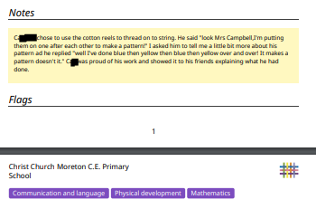
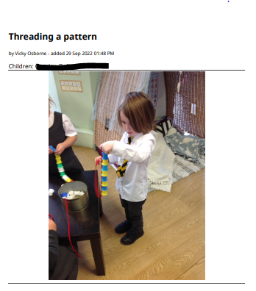

Example of observations completed on Tapestry (Ongoing Formative Assessment)
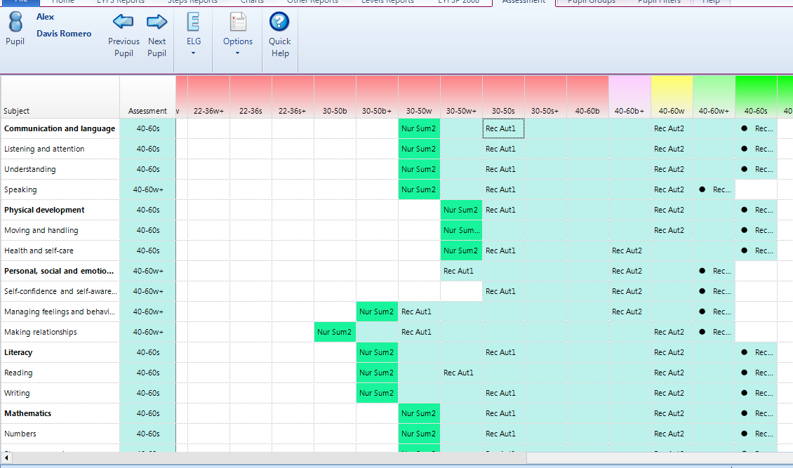
Example of data inputted into Target Tracker half termly (Summative Assessment)

5b) Quality Assurance and Moderation
In order to ensure judgements are accurate the following processes are followed in the EYFS at Christ Church for all EYFS staff.
- Regular EYFS team moderation of observations and assessments
- Regular moderation as part of a Wirral Church of England schools EYFS cluster group as well as across CDAT schools within our multi academy trust
- Part of whole school termly reviews of attainment and progress which include discussions with Senior Leadership staff and SENCO
All of the above contribute to ensuring all staff are making accurate judgements of children’s learning and development and allow quality assurance across the EYFS profile at the end of the academic year.

5c) Marking and Feedback
EYFS follow the whole school marking and feedback policy with the following adaptations and amendments.
Verbal feedback including strengths and next steps are given to all children in the Foundation Stage on a regular basis. This is carried out by all members of the teaching team. Children are provided with opportunities to contribute to and negotiate their own next steps and targets with members of the teaching team. As children’s development allows, this is recorded on children’s work with the image of steps used alongside TT (Teacher Talk) to indicate next steps have been discussed with children and agreed.
Written feedback is presented as part of the children’s individual learning journals, this is communicated to Parents/Carers and other adults with regular opportunities for Parents/Carers to contribute their own feedback and comments.

Targets are moderated and set for individual children on a regular basis. These are shared with Parents/Carers at regular times throughout the Foundation Stage. Parents/Carers are involved in this process and are kept up to date as part of our Positive Relationships work.

As learning and development allows in FS2, Assessment for Learning strategies such as Tickled Pink and Green for Growth will be introduced (see whole school Marking and Feedback policy for further information regarding this). These will include visual cues for children to become familiar with and to encourage the opportunity for children to respond. Pink and Green stampers will be introduced to begin with and this will progress to verbal feedback alongside pink and green written feedback with an opportunity for children to verbally respond and this be recorded in purple pen to be in line with the rest of the school’s policy.

Section 6
Positive Relationships

We recognise that parents/carers are children’s first and most enduring educators, and we value the contribution they make.

We recognise the role that parents/carers have played, and their future role in educating their children. We do this through inviting all parents/carers of EYFS children a variety of opportunities to develop links with the school such as:
- An induction meeting before their child starts to see the setting and meet the staff
- Accompanying their children to attend settling sessions and transition activities in their classroom and outdoor environment
- Offering informal ‘pop in’ visits after school hours where they can become familiar with the school premises and EYFS learning environment, prior to starting school.
- Offering the opportunity for children to visit school with their Key Worker from their previous nursery setting and parent/carer if required
- Offering parents regular opportunities to talk about their child’s progress. There is a formal meeting for parents each term at which the teacher and the parent discuss the child’s progress in private with the EYFS staff. Parents receive a report on their child’s attainment and progress at the end of each school year.
- Encouraging parents to talk to the child’s teacher/key person if there are any concerns by operating an ‘open door’ policy.
- Arranging a range of activities throughout the year that encourage collaboration between child, school and parents. For example: Stay and Play Sessions, Festivals and Celebrations, Parent Workshops.
- Providing opportunities for parents to contribute to their child’s learning journey through questionnaires, uploading achievements from out of school to Tapestry, and records of discussions, all relating to the children’s achievements.
- Providing a dedicated year band email address for parents/carers to contact school staff with queries or questions directly. EYFS staff respond to these emails within school hours, 8.00am to 6.00pm on weekdays.

All staff involved with the EYFS aim to develop good relationships with all children, interacting positively with them and taking time to listen to them. At Christ Church CE Primary School in EYFS the staff work as a Foundation Stage Team with all members of staff in each year group contributing to each child’s learning and development. We establish Key Person Roles within our settings to provide each child with one named member of staff, with whom they can form a particularly strong relationship. Each child will know who their key person is once they are settled in school. The children will spend quality time each week building their special relationship with them. This will be in addition to the positive and important relationships they will have with all members of staff. All members of staff will support all children and their parents, and work together for everybody’s best interests. We welcome parents to contact us with little queries / concerns but should parents be dissatisfied they are advised to follow whole school complaints policy.

Section 7
Transition

7a) Starting Pre School
Children are welcome to join Christ Church Pre School any time after the term in which they turn 3 years old. Ensuring our youngest children have a positive and happy start is a priority, working together to get to the know the child and family through the following process enables this to happen.
- Families are invited to visit the Pre School at any time in the year by arranging a visit with our EYFS leader via the school office when considering settings for their child to attend.
- Open stay and play sessions will be available for families to book throughout the year, giving them an opportunity to see the setting and meet the EYFS staff.
- Children are invited to attend two settling sessions with a family member in the half term prior to them starting in Pre School. During these sessions, they will spend time with our staff and join in with activities and play with their peers.
- EYFS staff will arrange for face to face or telephone calls prior to a child starting to discuss their individual development, any parental concerns or questions and share important information regarding Pre School.
- Families will have access to our Pre School email address once a place has been confirmed, enabling them to communicate directly with EYFS staff with any questions they may have.
- Our Welcome Booklet is shared with families in the term prior to their child starting with up to date information included.
We understand that some children may find separating from their main carer and settling into Pre School difficult, our EYFS staff will always work with families and ensure that additional, enhanced transition is planned on an individual basis, should this be required.

7b) Transition from F1/Pre School into FS2
At Christ Church we receive children from a number of different feeder settings including our own pre-school. We endeavour to provide a smooth and supportive transition process for all children and therefore provide the following:
- FS2 staff will contact all families once allocated places have been accepted to discuss their child and share important information about the transition process.
- FS2 staff undertake visits to all children in their pre school setting during the summer term where they can begin to build relationships, experience the child’s current learning environment and speak with the child’s key worker about learning, development and additional information.
- Parents/Carers are invited to school for a meeting during the summer term where information regarding starting school is shared as well as an opportunity for them to meet and chat with FS2 staff in the FS2 classroom.
- Parents/Carers are invited to bring their children to a number of different transition activities throughout the Summer Term to build relationships and experience activities and learning opportunities. These include a Forest School session; a swimming fun session; a Teddy Bears Picnic Stay and Play.
- Information shared from pre school settings informs class allocation along with term of birth and gender balance to ensure friendships are promoted and additional needs are supported.
- For children with additional needs or families that require further support, additional meetings are offered with relevant professionals / agencies to ensure all needs are supported effectively.
- Children begin school in the autumn term a day later than years 1-6 to ensure appropriate time is given to welcome children and families and provide for any additional settling needs.
- A flexible approach to starting school, taking into consideration children’s Personal Social and Emotional skills and prior Pre School/F1 experience to ensure all children are settled and happy when starting school full time.

7b) Transition to Year 1
We understand that the transition to Year 1 from FS2 can sometimes be challenging for children and families as children move out of their familiar EYFS provision, beginning to become more independent as their learning develops in structure. In recognition of this, we aim to provide a smooth and supported transition period including the following:
- Children will visit their new classrooms and work with the staff in Year 1 on regular occasions leading up to the end of the Summer Term.
- The provision and structure of the day in FS2 will progress throughout the year and as development allows, to encourage independence in preparation for Year 1.
- The provision in Year 1 will be carefully planned and matched to the children’s needs to allow them to continue to make progress.
- The FS2 and Year 1 Staff will liaise closely informally and during formal transition meetings, to ensure everyone has the knowledge and understanding of each child’s progress, ability and needs.
- Parents/Carers will be offered the opportunity to attend a transition themed stay and play session that provides key information on how best to support their child during this time.
- Parents/Carers will be invited to attend an informal ‘pop in’ session where they can meet and chat with Year 1 staff in the Year 1 classroom during the summer term.
- Parents/Carers will be given the opportunity to voice concerns/questions through questionnaires that will then be analysed by FS2 and Year 1 staff to ensure all families are supported.
- Opportunities during the Autumn term will be planned for parents to be involved in their child’s learning and to raise any concerns or questions with Year 1 staff.
- For children or families with additional needs, meetings will be arranged with FS2 staff, SENDCO, Year 1 staff and any other relevant professionals / agencies to ensure individual needs are effectively supported.

Transition into Pre School timeline
April - August | Applications for Pre School for children turning 3 years old between April and August can be submitted to school for a start in September
July | Transition settling sessions for children starting Pre School in the Autumn Term (September)
September - December | Applications for Pre School for children turning 3 years old between September and December can be submitted to school for a start in September
November / December | Transition settling sessions for children starting Pre School in the Spring Term (January)
January - April | Applications for Pre School for children turning 3 years old between January and April can be submitted to school for a start after the school Easter Holidays / Spring Break
March / April | Transition settling sessions for children starting Pre School in the Summer Term (April / after the school Spring Break)
Please note applications for children can be submitted to the school office in advance of these dates if you are aware of the sessions you will require.
Transition into FS2 timeline
March | Applications received from Local Authority  Governors rank these applications according to our admissions criteria
April | Offers are made to parents and school are informed of any new applicants
April | EYFS lead contacts all families and pre-school settings to discuss individual children and speak with Key Workers
Summer Term | Classes are allocated based on gender, additonal needs, relationships, term of birth
May-July | Children are invited to attend informal and formal transition opportunities (see above for examples of these)
June | Parents and Carers are invited to attend a formal welcome meeting which includes discussions with EYFS staff, a look around the learning environment and opportunities to speak with all other relevant school staff
June / July | Additional transition meetings and events are planned for any children with additional needs or requirements
September | Progressive transition into FS2 takes place with part time sessions building up to full time days
September | Parent meetings are held to allow staff to discuss individual children and families to begin to establish and form positive relationships that will best support children’s learning and development

Section 8
Behaviour

At Christ Church we recognise the importance of teaching children the values and beliefs that underpin learning how to behave appropriately. The whole school behaviour policy is followed in EYFS, with children being rewarded for effort, demonstrating positive behaviour and for individual achievements as well as understanding the need for reflection time following mistakes or incidents of inappropriate behaviour. Children are consistently taught the expectations of behaviour and how to develop socially, emotionally and morally to allow all children to achieve and be responsible for their own actions. There are different systems in place to approach behaviour:
- Class Charts. This is an online programme that is used to award children positive points for positive behaviour as well as noting behaviour that is unacceptable within school. Children accumulate points throughout the year and earn various rewards for achieving milestones in their points. Parents/Carers are given access to the programme via the website or app and can see points that are being awarded to children with the reason why included to support home-school partnerships.
- Star of the week. 2 children per class are awarded a certificate as ‘Star of the Week’ in a celebration assembly. These are awarded for any individual achievement.
- Kindness Captains. Each week 1 child is awarded the role of Kindness Captain. This is awarded for children that have been noticed by their peers and any school staff for displaying kind behaviour to others.
Children in Pre School will use visual prompts taken from Class Charts to promote positive behaviour choices. Staff will use language consistent to the rest of the school when managing behaviour and children will receive green stickers in response to demonstrating positive behaviours. These stickers will be given instantly with staff optimising all opportunities to teach our youngest children and help them develop socially and emotionally.

Alongside all of the above, positive praise is consistently used to encourage children and to ensure all children feel proud of their achievements. Should any child find it difficult to access whole class behavior systems, individual ones are devised with the school SENDCO, please see SEND for further information.

Example of Star of the Week and Kindness Captain certificates
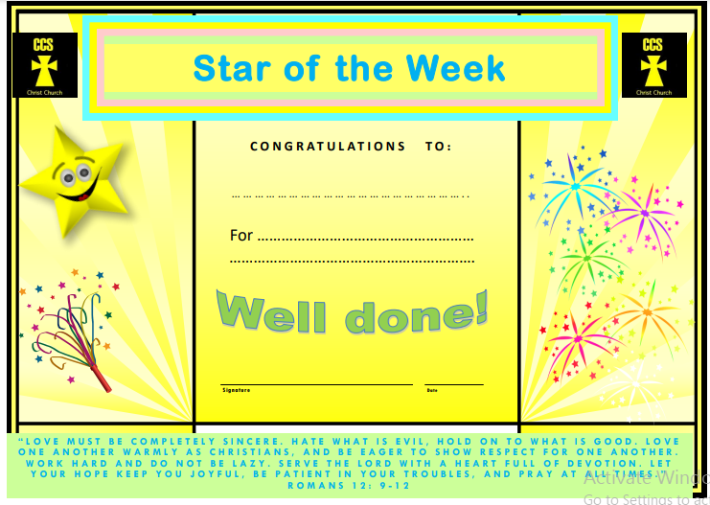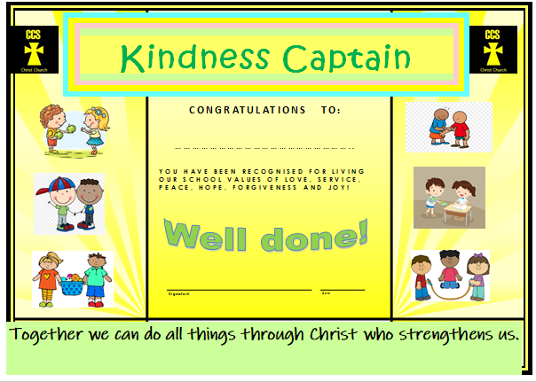

Example of a teacher view for Class Charts
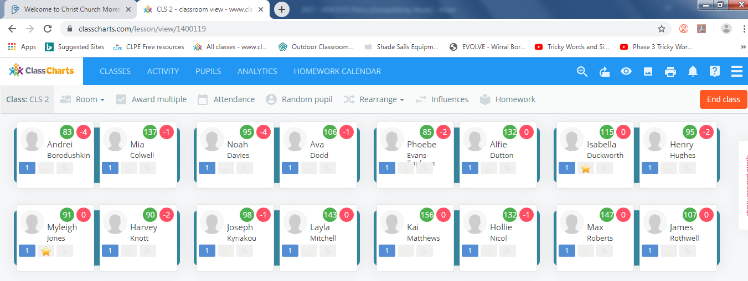

Section 9
SEND

Early identification of individual additional needs is of great importance and priority at Christ Church. Our Pre School staff work with our school SENDCO and families to discuss any concerns or additional needs as soon as possible to ensure any additional support can be put in place to support individual children. This information as well as transition information from external Pre School / F1 settings provides the basis of support for children with additional needs that are already identified prior to starting at Christ Church. For those children that have not received additional support or needs have not yet been identified, early identification allows targeted support to be implemented to ensure all children are included and needs are met.
The staff in EYFS have a strong relationship with the school SENDCO and work closely together throughout the year to effectively support all children with additional needs. Screening such as BPVS and WELLCOMM, as well as summative assessments and other recognised screening tests, are used on entry to Christ Church in both Pre School and FS2, to identify any areas of need, as well as at other points in the year to monitor and track progress. Meetings will take place regularly between the school SENDCO, EYFS staff and Parents/Carers to best plan support for all children with additional needs. External agencies are used to provide further support as well as offering advice alongside ‘in house’ support and guidance. Our school also employs a private speech therapist and educational psychologist to give us advice and specialist knowledge, along with contracts with the ADHD foundation and a close working partnership with CAMHS. The expertise from external professionals and the positive relationship between home and school is valued in ensuring all children enjoy and achieve in school.
Reasonable adjustments are made to all aspects of learning and development in the EYFS for children with additional needs and these are recorded accordingly following the school SEND policy.

Section 10
Inclusion

At Christ Church we embrace that all children are uniquely made with individual gifts and talents. We recognise that all children have the right to a happy, enjoyable and supportive education that allows them to achieve in all aspects of learning and development. We recognise the importance of early identification of children not achieving the expected level of development and strive to provide opportunities that will diminish the difference between those and others. For children and families with English as an additional language, adaptations are made to ensure they have access to school information in their home language where possible, translators or the Wirral organisation ‘MEAS’ are used to provide guidance and information in order to best support children and families in accessing all aspects of school. Cultural diversity is embraced and opportunities for children to access learning linked to this are carefully planned and delivered. For children from minority groups, the implementation of Characteristics of Effective Learning ensure staff are providing positive learning experiences for all. As per The Equality Act May 2014, all learning opportunities, practices, policies and procedures are reviewed regularly to ensure they are non-discriminatory and inclusive of all children and families.

Section 11
Sex and Relationships Education (SRE)

Within the EYFS of Christ Church, we follow the whole school SRE policy. Children are taught the importance of self care, keeping healthy and understanding the importance of respecting others. Schemes such as the NSPCC ‘Pants’ are used to ensure all children access age appropriate teaching of SRE and learn how to keep themselves safe. Our SRE teaching is part of the school’s Personal, Social and Health Education (PSHE), which has been written based upon the school’s Christian values and teachings in line with the Church of England. Our focus is helping children to be safe, to form positive, healthy relationships, to know how to look after their bodies and minds, to understand their role in looking after others and to know that they are loved and special.

Section 12
Safeguarding

As stated in the Statutory Framework for the Early Years Foundation Stage, March 2021, at Christ Church we realise that “Children learn best when they are healthy, safe and secure, when their individual needs are met, and when they have positive relationships with the adults caring for them.” And that we “must take all necessary steps to keep children safe and well.” We strive to provide a high quality setting that is “welcoming, safe and stimulating, and where children are able to enjoy learning and grow in confidence.”
In order to achieve this we follow the wholes school Safeguarding Policy which is based upon the requirements for ‘Keeping Children Safe in Education’.

At Christ Church we welcome additional volunteers, students and classroom assistants to support children’s learning alongside the school staff. Any additional adults that work within the EYFS at Christ Church are subject to an enhanced DBS and are provided with an induction process. The staff in EYFS follow the whole school policy and procedure for checking visitors when they come into our provision and environment.

Section 13
Health and Safety

“Children learn best when they are healthy, safe and secure, when their individual needs are met, and when they have positive relationships with the adults caring for them.” Statutory framework for the EYFS 2021

It is important to us that all children in our School are ‘safe’. We aim to educate children on boundaries, rules and limits and to help them understand why they exist. We provide children with choices to help them develop this important life skill. Children should be allowed to take risks, but need to be taught how to recognise and avoid hazards.
We aim to protect the physical and psychological wellbeing of all children.

At Christ Church CE Primary School we understand that we are legally required to comply with certain welfare requirements as stated in the Statutory Framework for Early Years Foundation Stage. We understand that we are required to:

- Promote the welfare of children.
- Promote good health, preventing the spread of infection and taking appropriate action when children are ill.
- Manage behaviour effectively in a manner appropriate for the children’s stage of development and individual needs.
- Ensure all adults who look after the children or who have unsupervised access to them are suitable to do so.
- Ensure that the premises, furniture and equipment is safe and suitable for purpose
- Ensure that every child receives enjoyable and challenging learning and development experiences tailored to meet their needs.
- Maintain records, policies and procedures required for safe efficient management of the setting and to meet the needs of the children.
- Complete risk assessments for trips, visits and curriculum enhancements
- Audit and monitor resources and the learning environment as part of routine site checks alongside the school site manager
- Ensure that contact details are up to date for children to enable staff to contact parents if children are ill or have an accident, including toileting. We follow the following whole school policies Managing and administering medication / NHS guidance for staying off school for specific illnesses / Accident reporting / First Aid. Please note our school has a full health and safety policy so this policy should be read in conjunction with that policy.
- Keep all children safe by operating as part of the whole school Emergency Evacuation procedure including fire drills and management of children in emergency situations.
- Ensure children are dropped off at school and dismissed safely following the whole school Drop off and Dismissal Policy. All staff recognise the importance of building relationships with families to ensure children are handed over to an appropriate adult at the end of each school day. In the unlikely event of a child not being located, the EYFS follow the whole school Missing Child Procedure.

We endeavour to meet all these requirements.

Section 14
Intimate Care

At Christ Church we believe that every child has the right to feel safe and secure in school. We recognise that the intimate care of children cannot be separated from other aspects of their learning and development. We welcome all children in to our Pre School and School, regardless of if they have or have not yet reached a stage where they can manage their own personal hygiene. We strive to provide appropriate support for each child on an individual basis and recognise the importance of seeking the child’s needs, views and feelings when carrying out any intimate care. It is our intention that every child should be attended to with respect and dignity when intimate care is given.

For any instances where Intimate Care is required to be given for a child the following procedures will be adhered to:
- For any child that is in Pre School and has not yet reached an independent development level of self care, this policy and procedures outlined will be followed
- Individual Intimate Care plans will be written with Parents / Carers for children with specific additional needs. Where any specialist procedures are required, suitable training for staff that work with the child will be sought and kept up to date
- School staff will discuss with Parents / Carers, a preferred procedure for supporting the child in developing independent self care and toileting skills. Familiar routines from home will be followed as much as possible to ensure the child feels safe and secure at all times in school
- Parents/Carers will be asked to provide nappies and wipes for their child in circumstances that a child is not yet toilet trained and requires regular changing/intimate care
- A child’s Key Person or a known familiar adult in school will carry out any necessary changing procedures with the child
- Children will always be supported to achieve the highest level of independence in any intimate care situation, teaching and learning will be included as part of these moments to ensure children are learning the skills required to become independent where possible
- Any staff undertaking intimate care with a child will seek to gain consent from the children, at an age appropriate level
- Staff will carry out any intimate care in appropriate changing spaces throughout school. Pre School have a designated toileting area with adequate changing resources and space for younger children, for older children within school, changing facilities are available in designated toileting spaces.
- Parents/Carers will be informed at the end of a Pre School session / end of the school day that intimate care procedures have been carried out for their child. This will be done via a home school book for Pre School children and face to face or telephone communication for older children in school
- Records of intimate care will be kept daily, indicating the child; reason for requiring intimate care; date and time; procedure followed and the member of staff carrying out the care
- We appreciate that sometimes children have toileting ‘accidents’ which are out of character for them. In the event of this, and in the absence of a personal intimate care plan, the child would be fully encouraged and supported to achieve the highest level of independence in cleaning themselves that is possible given their age and ability. Staff will encourage the child to do as much for his/herself as possible and parents will be informed the same day. On the rare occasion that a child is soiled to a point where they are unable to be cleaned to a comfortable state, parents would be contacted to advise or to collect their child if preferred.

Guidelines school staff will follow for changing children:
- If possible children should be changed standing. Staff should avoid lifting children where possible. Age appropriate changing mats or facilities will be used for children that are unable to be changed standing up
- The child’s skin should be cleaned with a disposable wipe
- Nappy creams/lotions should be labelled with the child’s name and used only if prescribed for that
- child they must not be shared. Over the counter medicines cannot be used unless a permission to give medication form is completed and stored in the classroom.
- Disposable gloves should be worn when changing nappies. The nappy should be folded inward to
- cover faecal material and double wrapped in a nappy bag. Soiled nappies should be disposed of safely.
- Any soiled or damp clothing should be placed in a plastic carrier bag for the child to take home. This should be done discreetly.
- Once the child has been changed and removed from the changing area, the surface should be
cleaned with an antibacterial detergent spray or wipe and left to dry.
- Gloves, apron and any items used for cleaning the changing area will be wrapped and disposed of via domestic waste.
- Hands should be thoroughly washed afterwards.
- Complete the intimate care record if the child has an individual plan or inform parents as outlined above where no such plan is in place.

Section 15
Monitoring and Review of the EYFS
- It is the responsibility of the staff delivering the EYFS to follow the principles stated in this policy.
- All staff working within the EYFS with contribute to the process of Self-Evaluation working with the Headteacher.

- The Headteacher, SLT and EYFS Leader will carry out monitoring on the EYFS as part of the whole school monitoring schedule. (See whole school monitoring for further information)

